UGC Sponsored National Seminar on “Value and Importance of Mathematical Physics” (NSVIMP-2015) - 05 Dec, 2015

CONTENTS
1. Sanctioned Letter
2. Summary of National Seminar
3. Organizing Committee
4. Flex, Banner, Poster, Brochure
5. Proposal of Seminar
6. Photograph/Image
7. Press release
8. Feedback form
9. Statement of expenditure and utilization certificate
10. Detail of head wise bill

Sponsored by:
University Grants Commission
New Delhi
Sanction Letter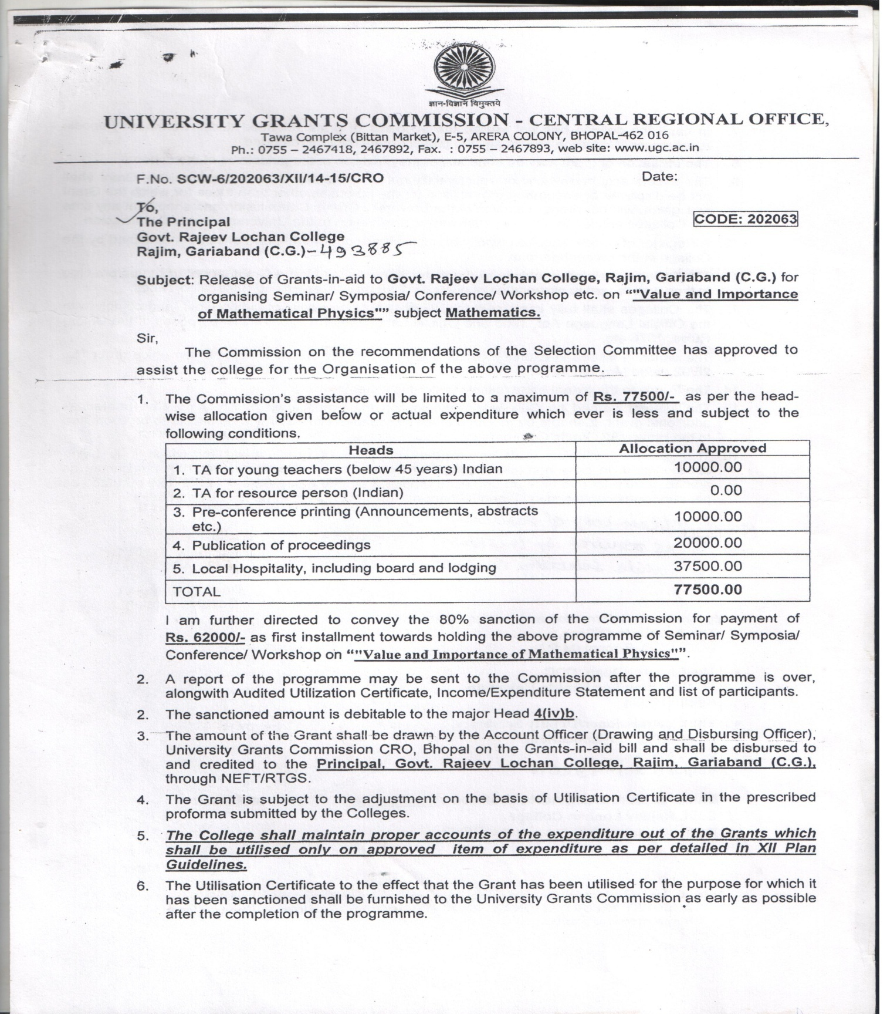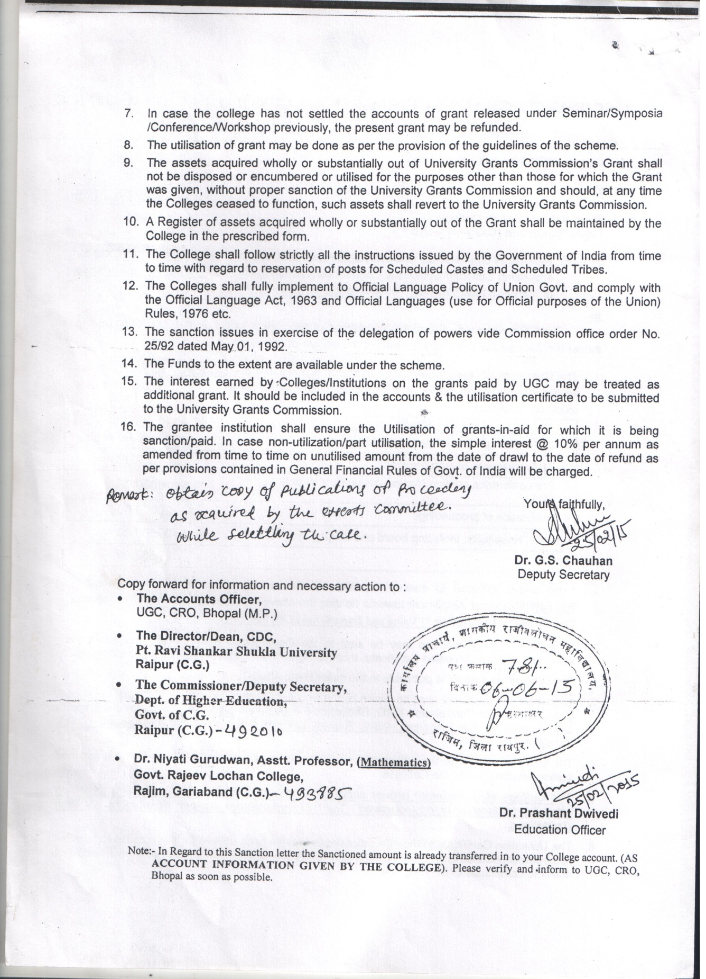
REPORT
National Seminar
On
Value and Importance of Mathematical Physics (NSVIMP-2015)
About the Institution
Govt. Rajeev Lochan College is situated at Rajim city of Gariaband district in Chhattisgarh. Rajim is also known as “Prayag” of Chhattisgarh, since it is located on the bank of trinity of three rivers Mahanadi, Pairi & Sondhur. This place is also famous for its rich cultural heritage and beautiful ancient temples as Shri Rajeev Lochan Mandir of Lord Vishnu and Kuleshwar Mahadev Mandir of Lord Shiva.
The college was established in 1972 by local eminent educationalist as a private institute in a rented building. It was undertaken by Government in 1981 and shifted to its own building in 1991. It is affiliated to Pt. Ravishankar Shukla University, Raipur (C.G.) and also 2(f) & 12(b) notified by UGC in 1992. Department of Mathematics and Physics was established in 2001. At present 130 students are studying in B.Sc. Mathematics Group. The College offers Undergraduate degree courses of B.Sc. (Maths. & Bio.), B.Com, B.A. and Postgraduate degree courses of M.A. (Political Science, Economics, Hindi) and M.Com.
About the UGC
The University Grants Commission (UGC) of India is a statutory body set up by the Indian Union government in accordance to the UGC Act 1956 under Ministry of Human Resource Development and is charged with coordination, determination and maintenance of standards of higher education. It provides recognition to Universities in India and disburses funds to such recognized universities and colleges. Prof. Ved Prakash is the incumbent Chairman of UGC, India. Its headquarter is in New Delhi, and six regional centers in Pune, Bhopal, Kolkata, Hyderabad, Guwahati and Bangalore.
About the Activity

Mathematics is regarded as a tool and bone for the Physical Science. Many natural events in our daily life are directly correlated to Physics as well as Mathematics. Mathematical Physics is useful tool for many branches of Science and Technology and is also applicable in many advanced research activities. The aim of this seminar was to provide an opportunity to the eminent scientists and technologists to share their knowledge, experiences and exchange ideas on various aspects related to the current advances in the fields of mathematical physics. Also the seminar featured the development of scientific approach amongst the students to understand the mathematical elements involve in physics and its applications in science technology and industries.
The main focus of the Seminar was to accelerate the knowledge of fundamentals of mathematical science, physical science and the development of innovative ideas of current research in science and technology. The concept of the seminar was based on exchange of innovative ideas from academicians, scientists, engineers, researchers and PG students from different universities, colleges, research institutes. The other aspect of the seminar was to develop scientific approach, innovative methods, phenomena and new technologies among the young researchers and rural science students. In the seminar, persons from different fields exchanged and shared their experiences and research results related to various aspects of Mathematical Physics and discussed the challenges encountered and the solutions adopted, hence enhanced their development and facilitated the emergence of new technologies in our state and country. The seminar aimed to create a platform for young researchers in the field of Mathematical Physics to interact with eminent personalities in the respective field. The seminar started with key note address followed by invited talks by eminent scientists, professors and academicians with oral presentations on recent trends in Mathematical Physics, Computational Science, Theoretical Physics, Advance Mathematical Science and Mathematical Modeling given by participants. Topics as Cryptography, Hydrodynamics, Cosmology, Big bang theory, Thin film science, Modeling, Simulation and relation between Physics and Mathematics was covered.

National Seminar on “Value and Importance of Mathematical Physics” was the first attempt in the whole region of Rural Gariaband district that the college organized a national seminar in the field of mathematics and physics. It was a historical moment for the college.

Summary of Seminar
National seminar on the theme “Value and Importance of Mathematical Physics (NSVIMP-2015) was held at Govt. Rajeev Lochan College, Rajim, Dist.-Gariaband (C.G.) on 5th December 2015. This was a historical moment for the college. More than 150 participants participated from various academic institutes and universities in Chhattisgarh as well from different regions of India. The seminar was inaugurated by Dr. S.K.Pandey, Hon. Vice Chancellor, Pt. Ravishankar Shukla University Raipur, who was the Chief Guest of the programme. Prof. S.K.Pandey explained in his inaugural lecture the importance of research in Physics and Mathematics from ancient era to modern era and how it is beneficial for human beings. He further talked about the importance of seminar, workshop and conference. He said that these type of programs are platform to exchange idea, view, concept, method and technology with each other. He highly appreciated and congratulated the organizers for organizing the national seminar for the first time in the college. Objective of the seminar was presented by Mr. Goverdhan Yadu, Asst. Prof. (Physics). Dr. Preeti Tiwari, Principal, Govt. Rajeev Lochan College Rajim, delivered the welcome address highlighting the importance of Mathematical Physics. She said that this seminar has played a central role in the advancement of several research disciplines including biological, mathematical and physical sciences to the problems of current issues in daily life. The programme was presided by Dr. B.K. Sharma, Prof. S.O.S. in Mathematics, Pt. R.S.U. Raipur (C.G.). Dr. Sharma gave a historical perspective of the Mathematical system from Ancient to current time. He focused on motivating the students toward mathematics and physics. According to him, rural students are hard workers and equally talented. He explained the importance of the two basic science subjects- Mathematics and Physics as tools in the modern era of technology. Prof. Sharma thanked the organizers for providing the opportunity to visit this historical place of Chhattisgarh, Rajim, which is although a small place but is full of history, culture, mediation, yoga as well as science importance. Further the program was followed by the address of Mr. Pawan Sonkar, President, Nagar Panchayat, Rajim. He appreciated and thanked the college for conducting a national level program on science subject. The programme was concluded by the vote of thanks by Dr. Niyati Gurudwan, Organizing secretary (Asst. Prof.- Mathematics).
Other dignitaries who participated in the seminar included national level renowned academicians: Dr. H.K.Pathak, Prof. and H.O.D, S.O.S. in Mathematics, Pt. R.S.U., Raipur, Chhattisgarh, Dr. C.L.Dewangan, Principal, Govt. Navin College, Fingeshwar, Dr. O.P.Dubey, Principal, Govt. Kachana Dhurva College, Chhura, Dr. D.S.Jagat, Principal, Govt. Veer Surendra Sahae College, Gariaband, Dr. Navin Chandra, Asst. Prof., Dept. of Physics, Hazaribagh University, Jharkhand, Dr. Balram Ambade, Associate Prof. and Assistant Registrar, National Institute of Technology, Tatanagar, Dr. B.S.Thakur, Associate Prof., S.O.S. in Mathematics, Pt. R.S.U., Raipur, Chhattisgarh, Dr. Amitabh Baneerji, Principal, Govt. College, Nagari-Sihawa, Dist. Dhamtari, Chhattisgarh, Dr. P.B.Hariharno, Director, Seth P.C. College, Nawapara, Shri Sandeep Soni, Asst. Prof., Dept. of Physics, Govt. College, Balod, Chhattisgarh, Prof. B.R.Verma, Asst. Prof., Dept. of Physics, Govt. College, Kurud, Dist. Dhamtari, Chhattisgarh. Over all, the one-day event had accommodated optimally 30 participants and 155 students with young researchers in the well-arranged scientific sessions. The seminar was designed in a highly motivated manner with optimal time for presentations and lectures. This seminar greatly provided the opportunity to the youngsters to discuss and interact with eminent faculty members.

Technical session I
The first session of the national seminar started with the invited talk of the expert Dr. Navin Chandra, Associate Prof. (Physics), Hajaribagh University, Jharkhand. He presented the talk in the use of Mathematics and Physics in the field of biology. He elaborated how the structure of DNA, RNA can be nicely explained by using Mathematical Simulation. He explained about the XRD pattern, SEM structure and TEM Structure of human body long with RNA, DNA and Genes. Further he talked about the role of Mathematical physics in biology. The second speaker was Dr. B.S. Thakur, Associate Prof. (Mathematics), School of Studies in Mathematics, Pt. Rvishnkr Shukl University, Raipur. He gave the lecture about cantor set in Mathematics and thus explained the Euclidean Geometry. He nicely explained the scientific base of Mathematical set. He also explained that the number theory provides the base of digital electronics which is highly beneficial in modern era of Technology. Shri Sandeep Soni, Assistant Prof. (Physics), Govt. College Blod, Chhattisgarh, spoke on the importance of Stationary States in Quantum Mechanics. Mathematical Physics is the back bone of science and technology. Several mathematical topics plays important role in advance physics as operator, function, probability theory, numerical analysis, mathematical modeling etc. He nicely related the entire mathematical fundamentals in unique manner.
Technical session II
In the second session Dr. Amitabh Banerji, Principal, Govt. College, Nagri, Chhattisgarh, explained cryptography in modern mathematical scenario. Cryptography is the new research area in recent era of science and technology. Numbers give much more approximation of the terms in mathematical physics. He also explained Cantor set, number theory and operator theory, explaining the hope for future research in mathematical modeling and simulation. He also discussed how and when physics and mathematics help each other. Dr. Balram Ambade, Associate Prof., N.I.T. Tatanagar, explained how mathematics and physics are highly related to each other in every aspect of science and technology. He also explained some daily life events related to Physics and Mathematics. He gave useful talk on current research areas in Mathematical Physics. Shri B.R.Verma talked about the role of Mathemaical physics in the Material science. He also explained the behavior Luminescence material in term of Mathematical parameter. He also told about the thin films preparation and characterization. He nicely discussed the basic of mathematical physics in the preparation of material. After the lectures of the experts, research papers were presented by the participants. Panel discussed on how to integrate teaching and research in Mathematical Physics and what are recent areas in which research can be carried out. The session was chaired by Dr. B.S.Thakur, Asssociate Prof., SOS in Mathematics, Pt. R.S.U Raipur, and co-chaired by Dr. Navin Chandra, Department of Physics, Hazaribagh University, Jharkhand. In the introductory remarks, Dr. B.S.Thakur motivated the students to recognize the research challenges that different branch of physics and Mathematics offers. Physics explains large number of phenomena, for example, flying of birds in terms of biomechanics or biology at structural level. Dr. Chandra made clear that many physicists of today in fact had their basic education in pure mathematics/physics/computer science, indicating that the passion for physics which is more important than the previous basic science background/ degree that one holds. He also appealed the science students to overcome from the fear of physics and pursue physics as a career. Oral/written feedback had been taken from the participants after the session.
In the concluding session, our chief guest was Dr. H.K.Pathak, HOD, SOS in Mathematics, Pt.R.S.U. Raipur, Chhattisgarh. He is also famous writer of books in Mathematics of Graduate as well as Post graduate level. He gave nice lecture related to mathematical modeling of physical system. He explained the thermo-dynamical and hydro-dynamical system, fluid mechanics and other branches of physics. He told that mathematics is the future perspective for the modern researchers and young faculties. The seminar was concluded with the distribution of certificates amongst the participants by Chief Guest Dr. H.K.Pathak.

Organizing Committee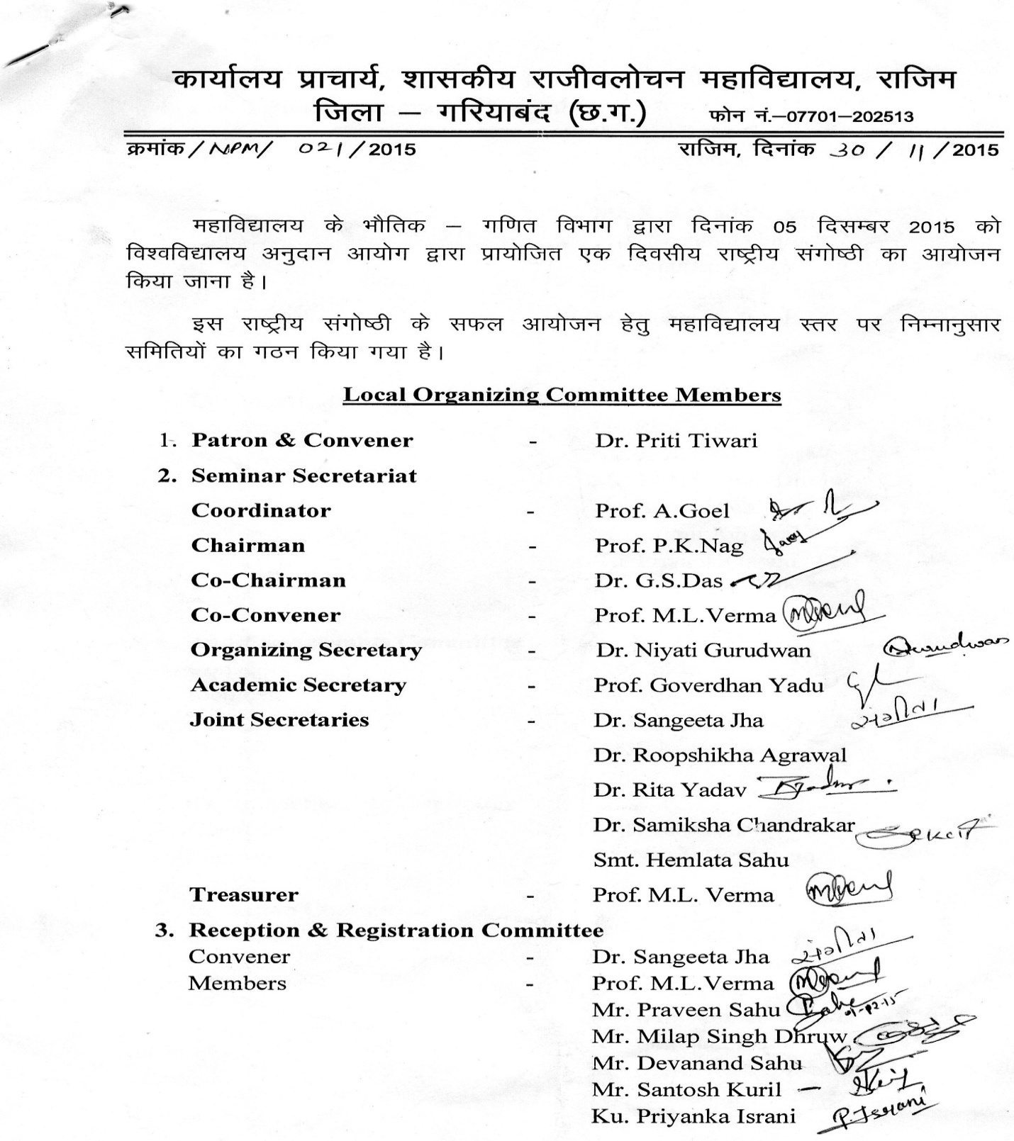
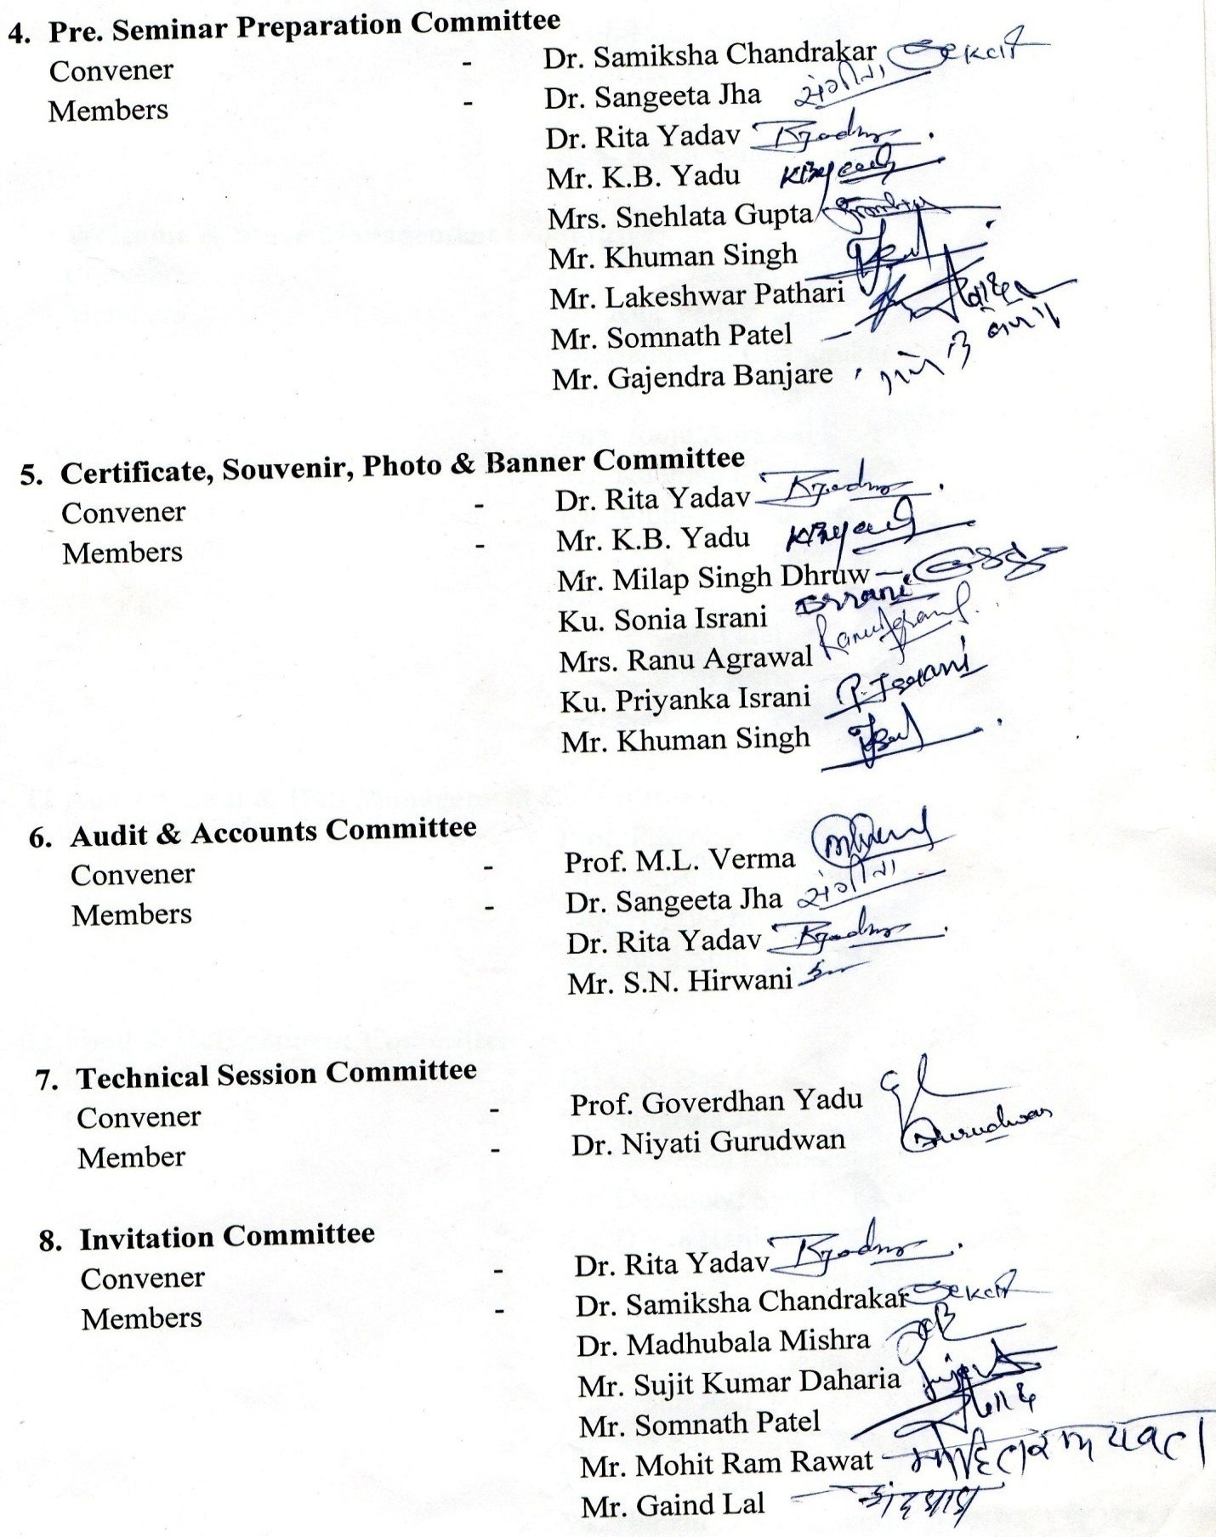
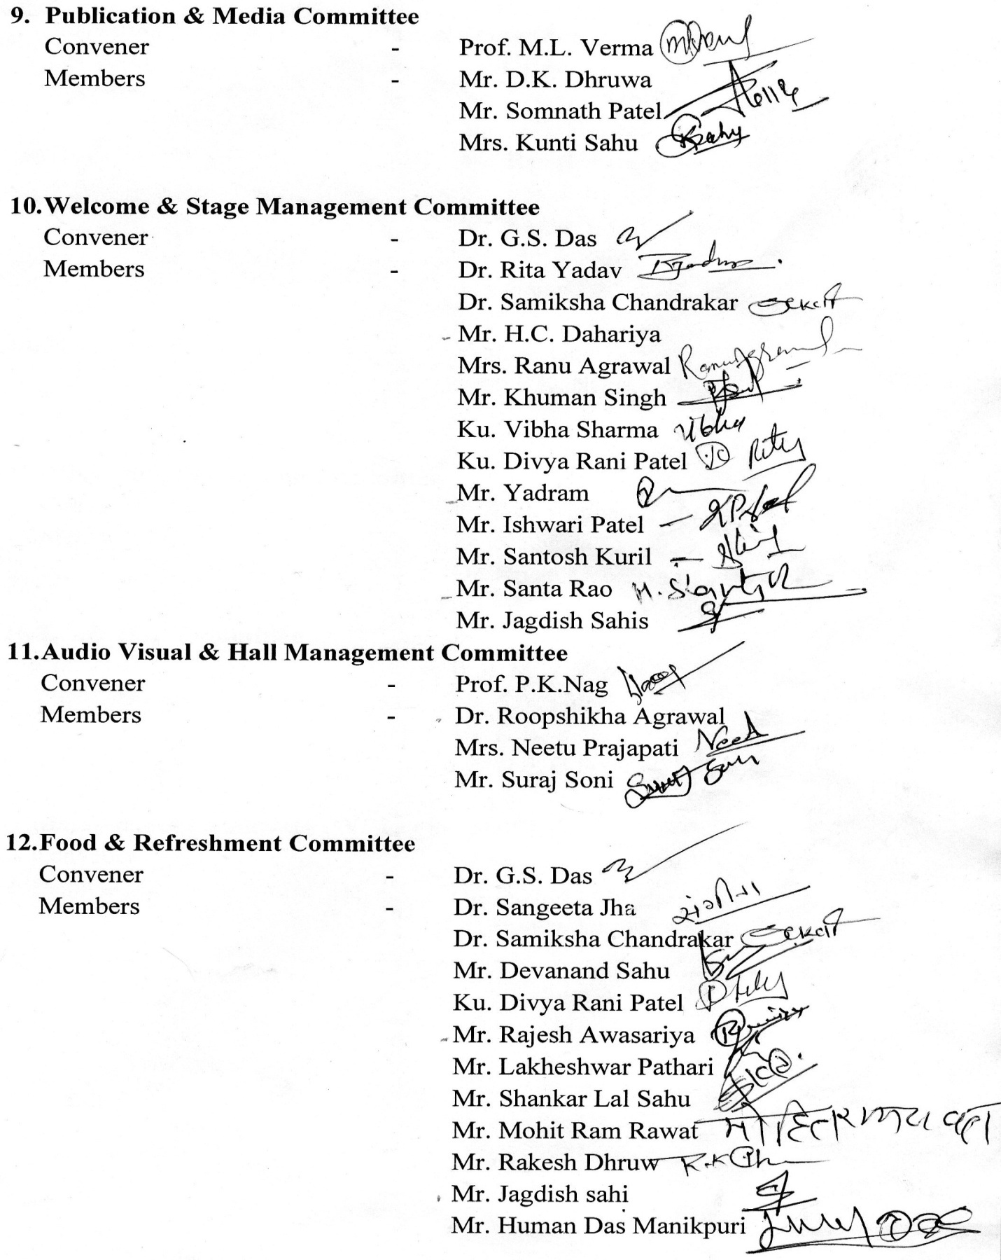

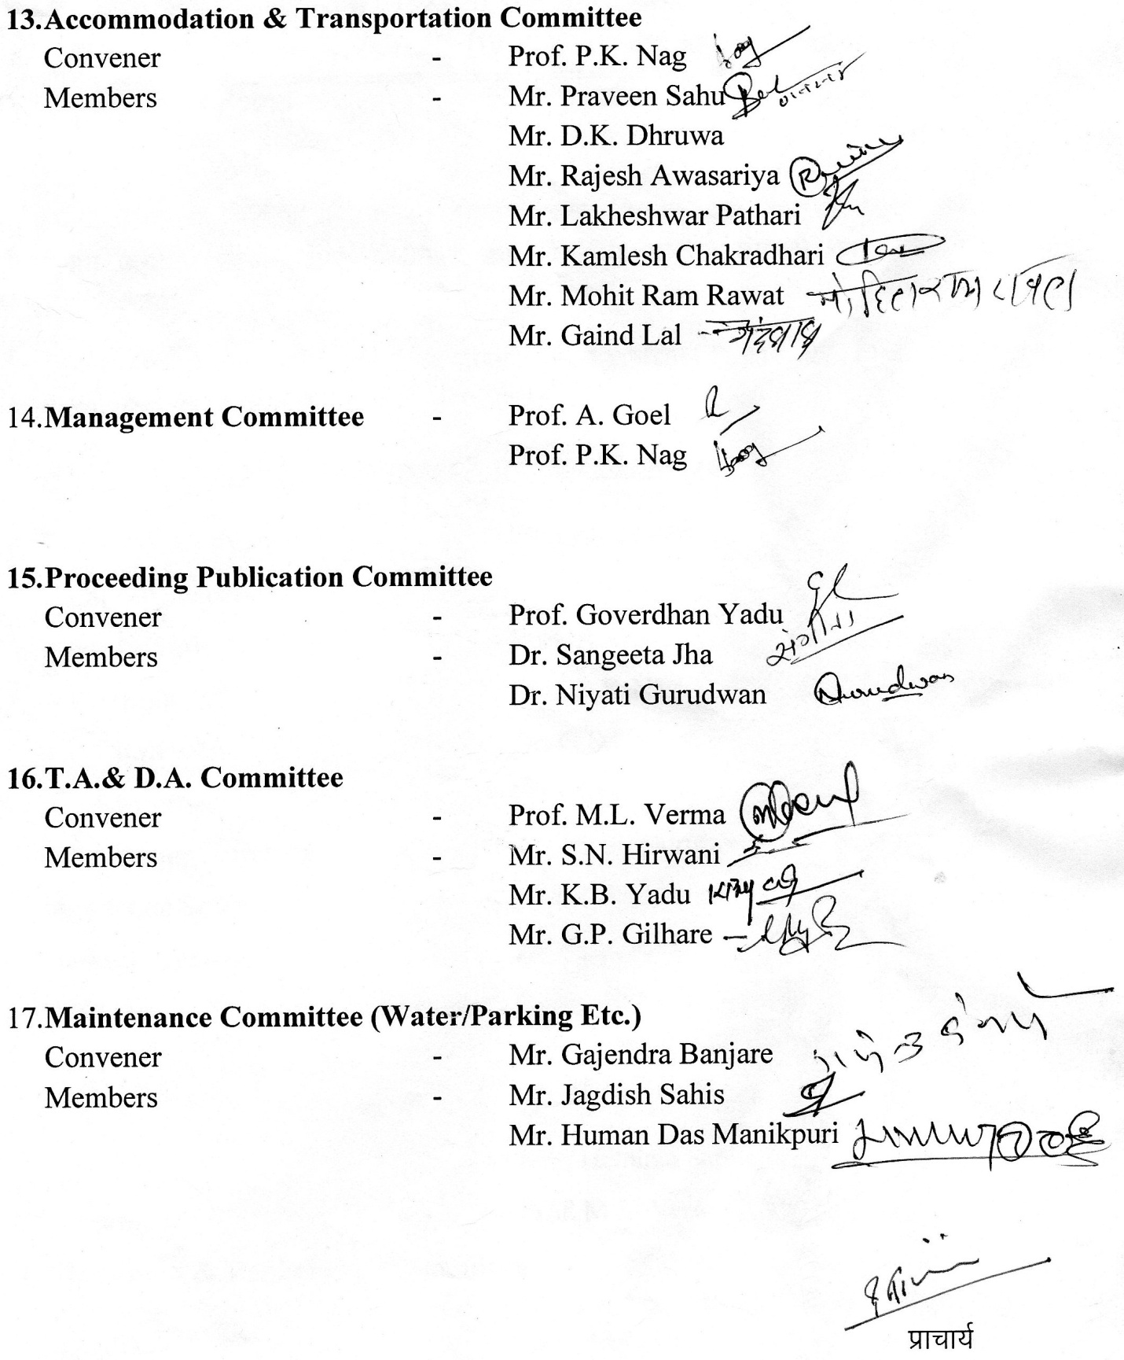

Brochure
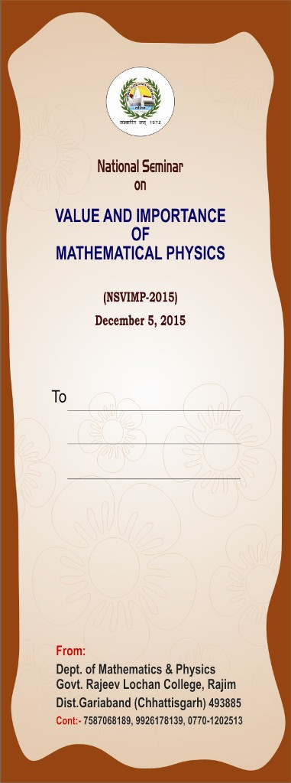

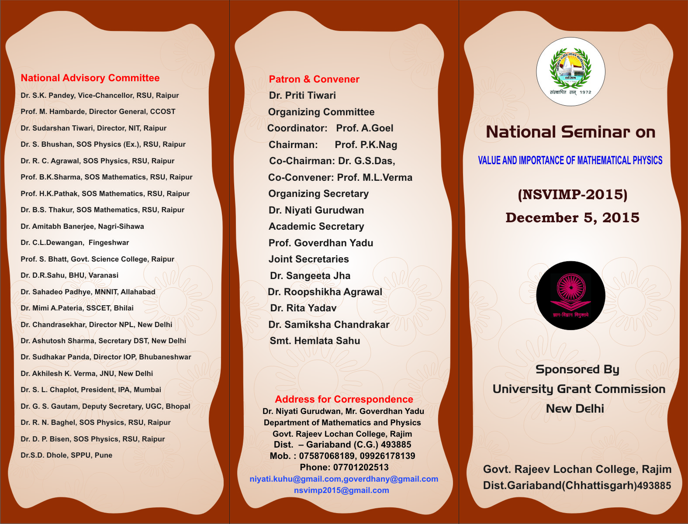

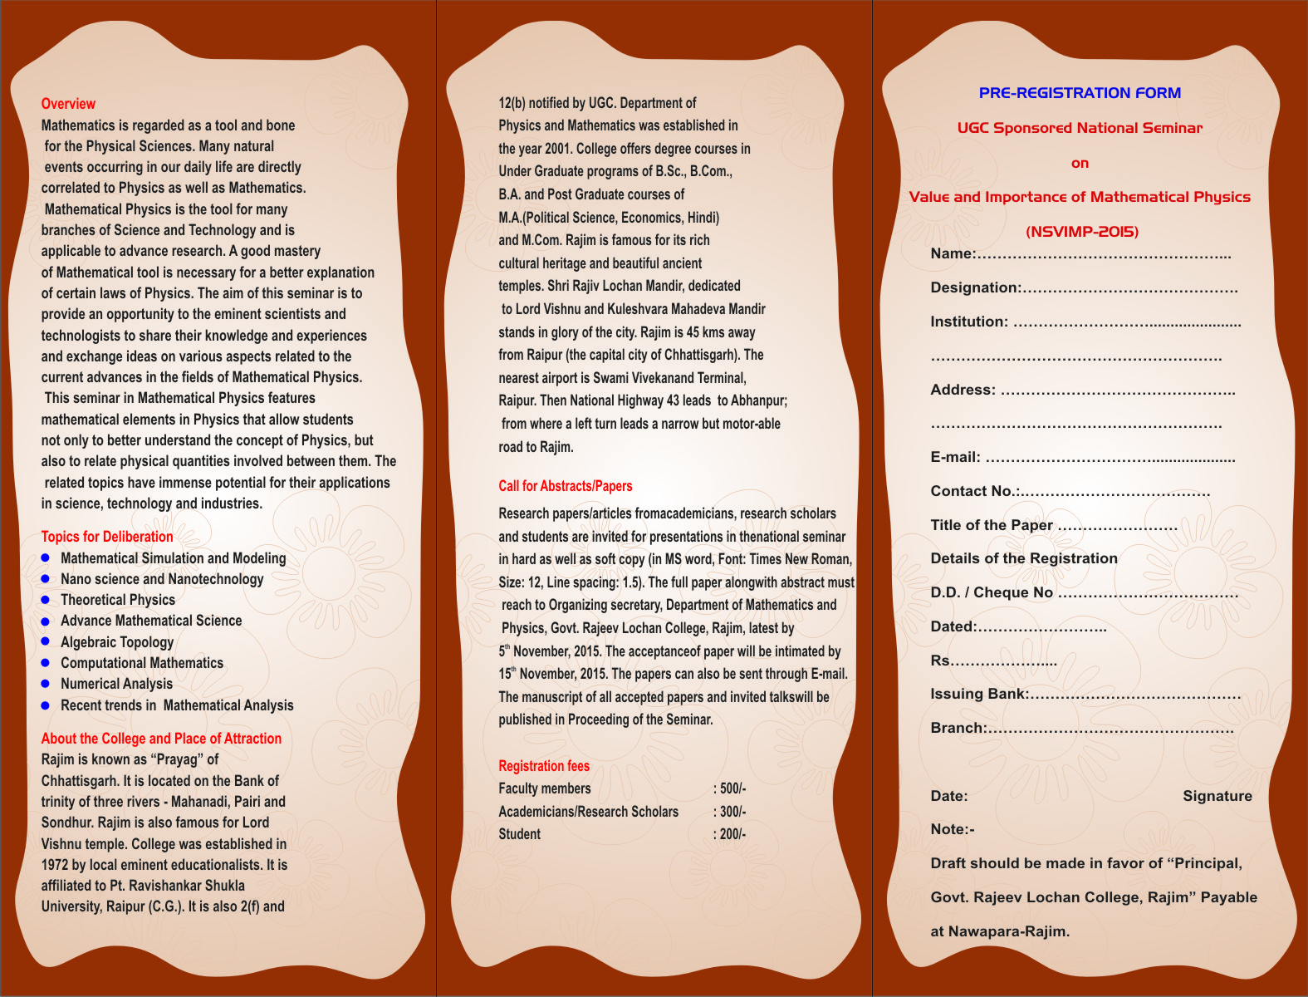

Banner

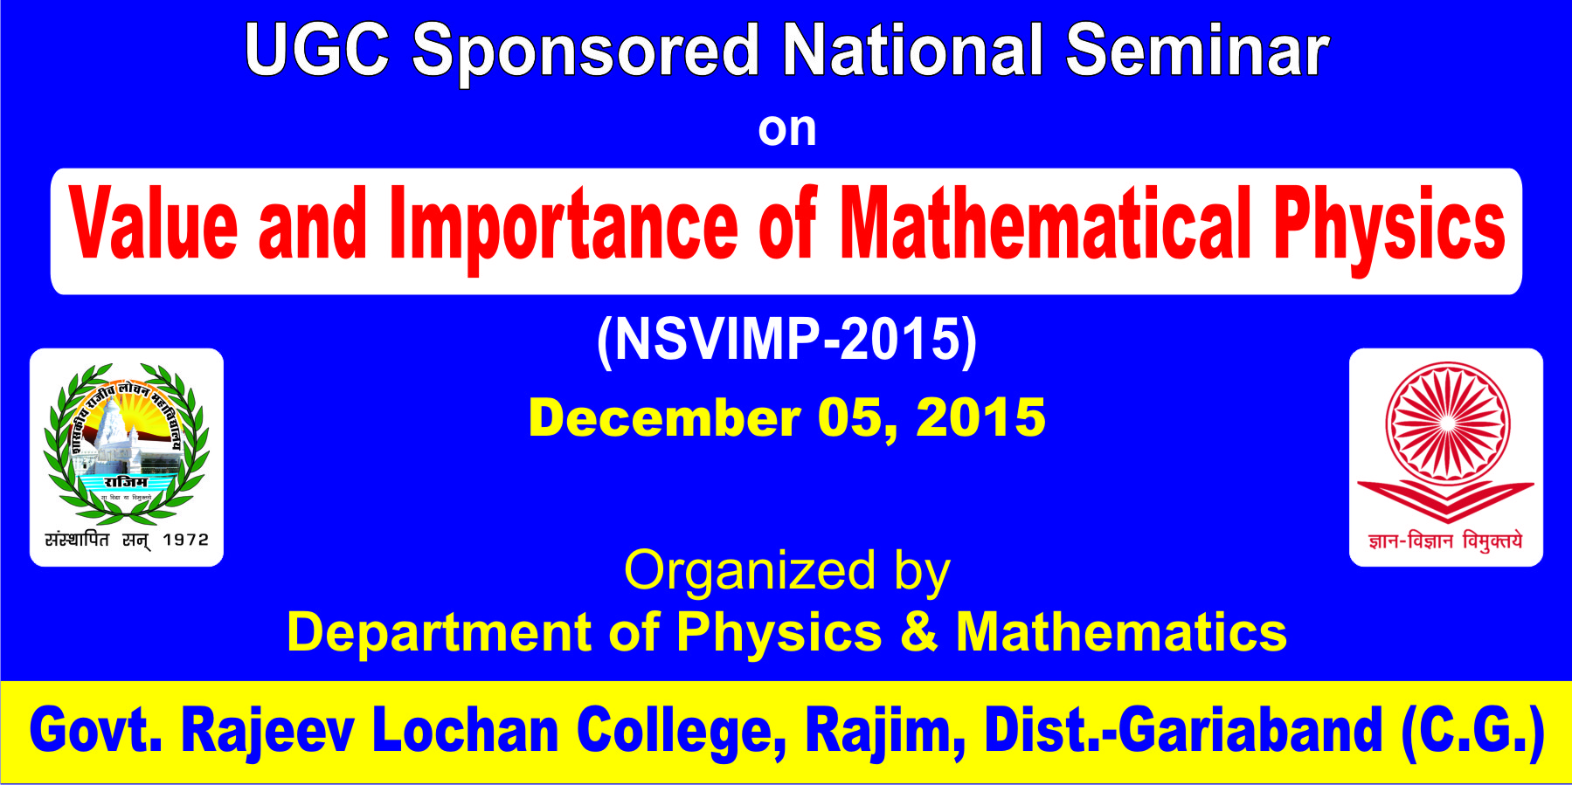

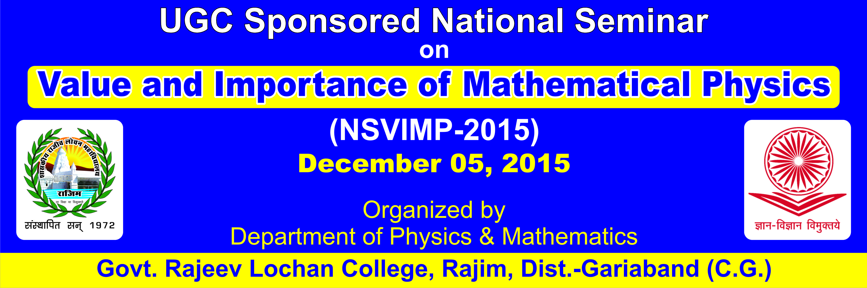

Certificate
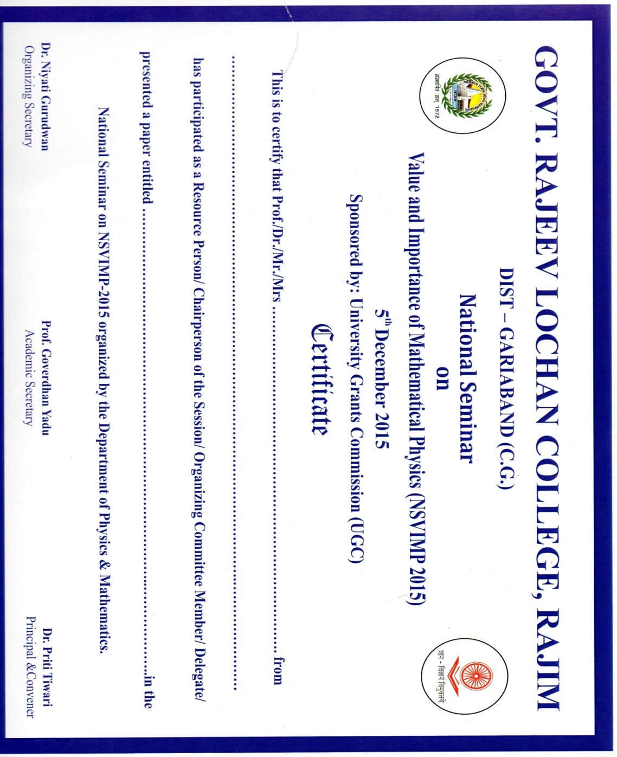

Invitation Card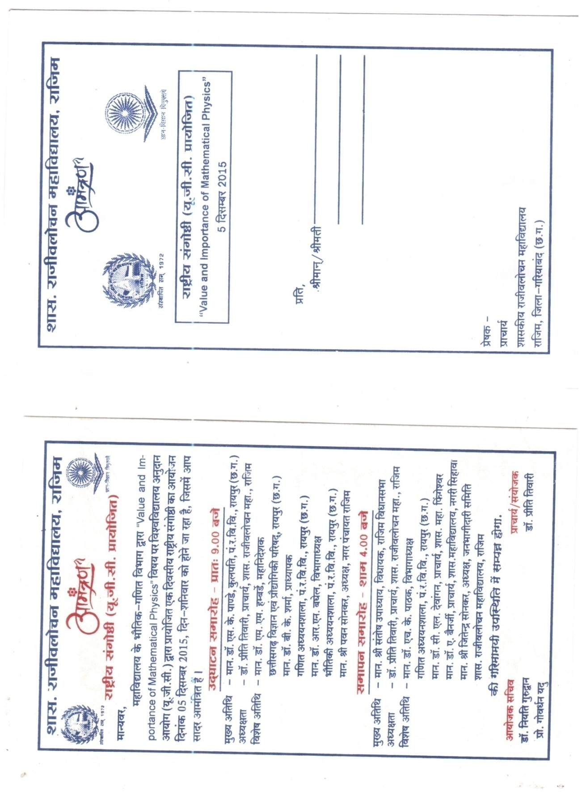
Receipt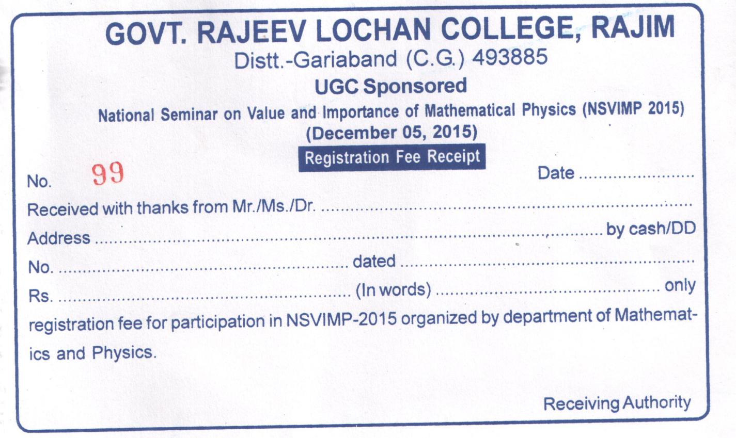

Feedback Form of Participants
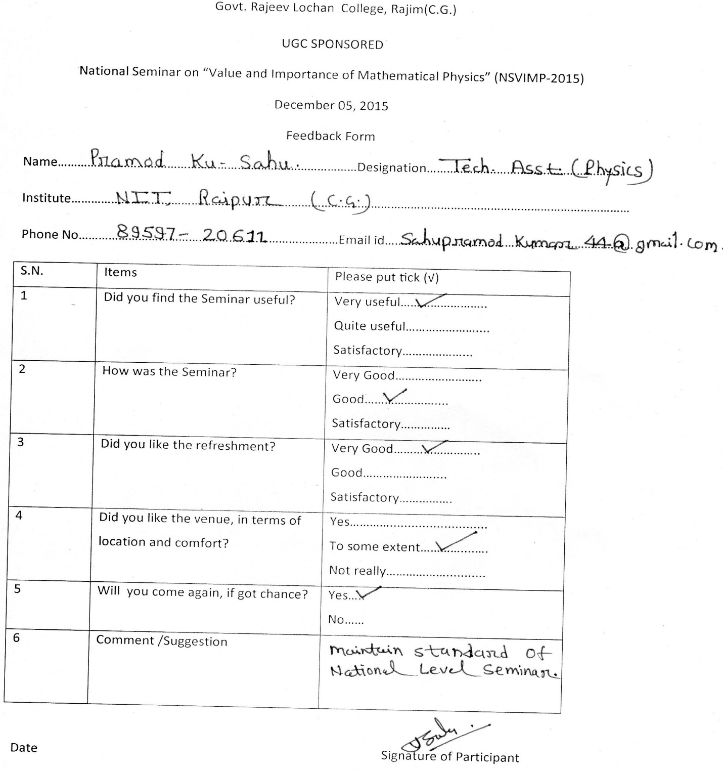

s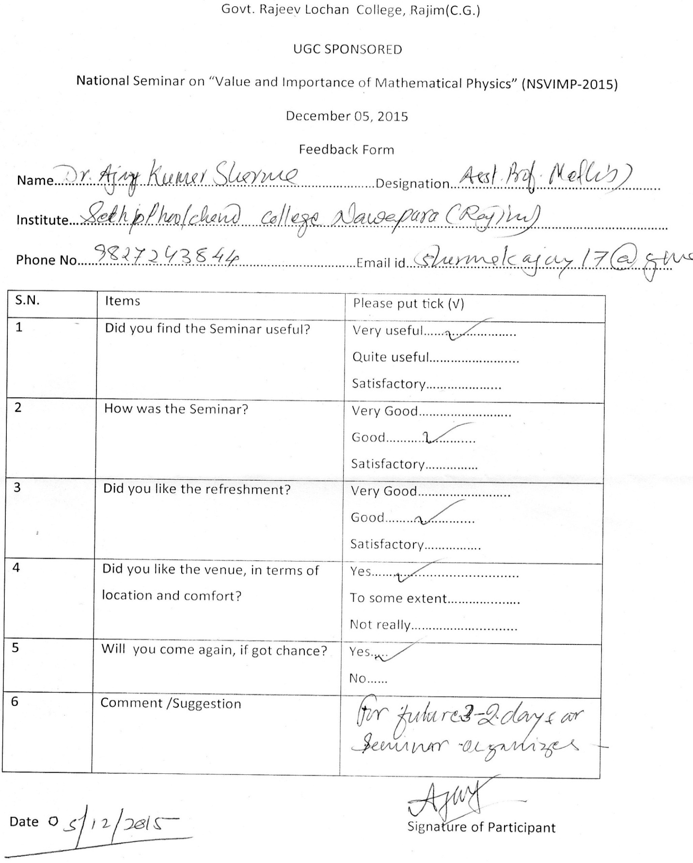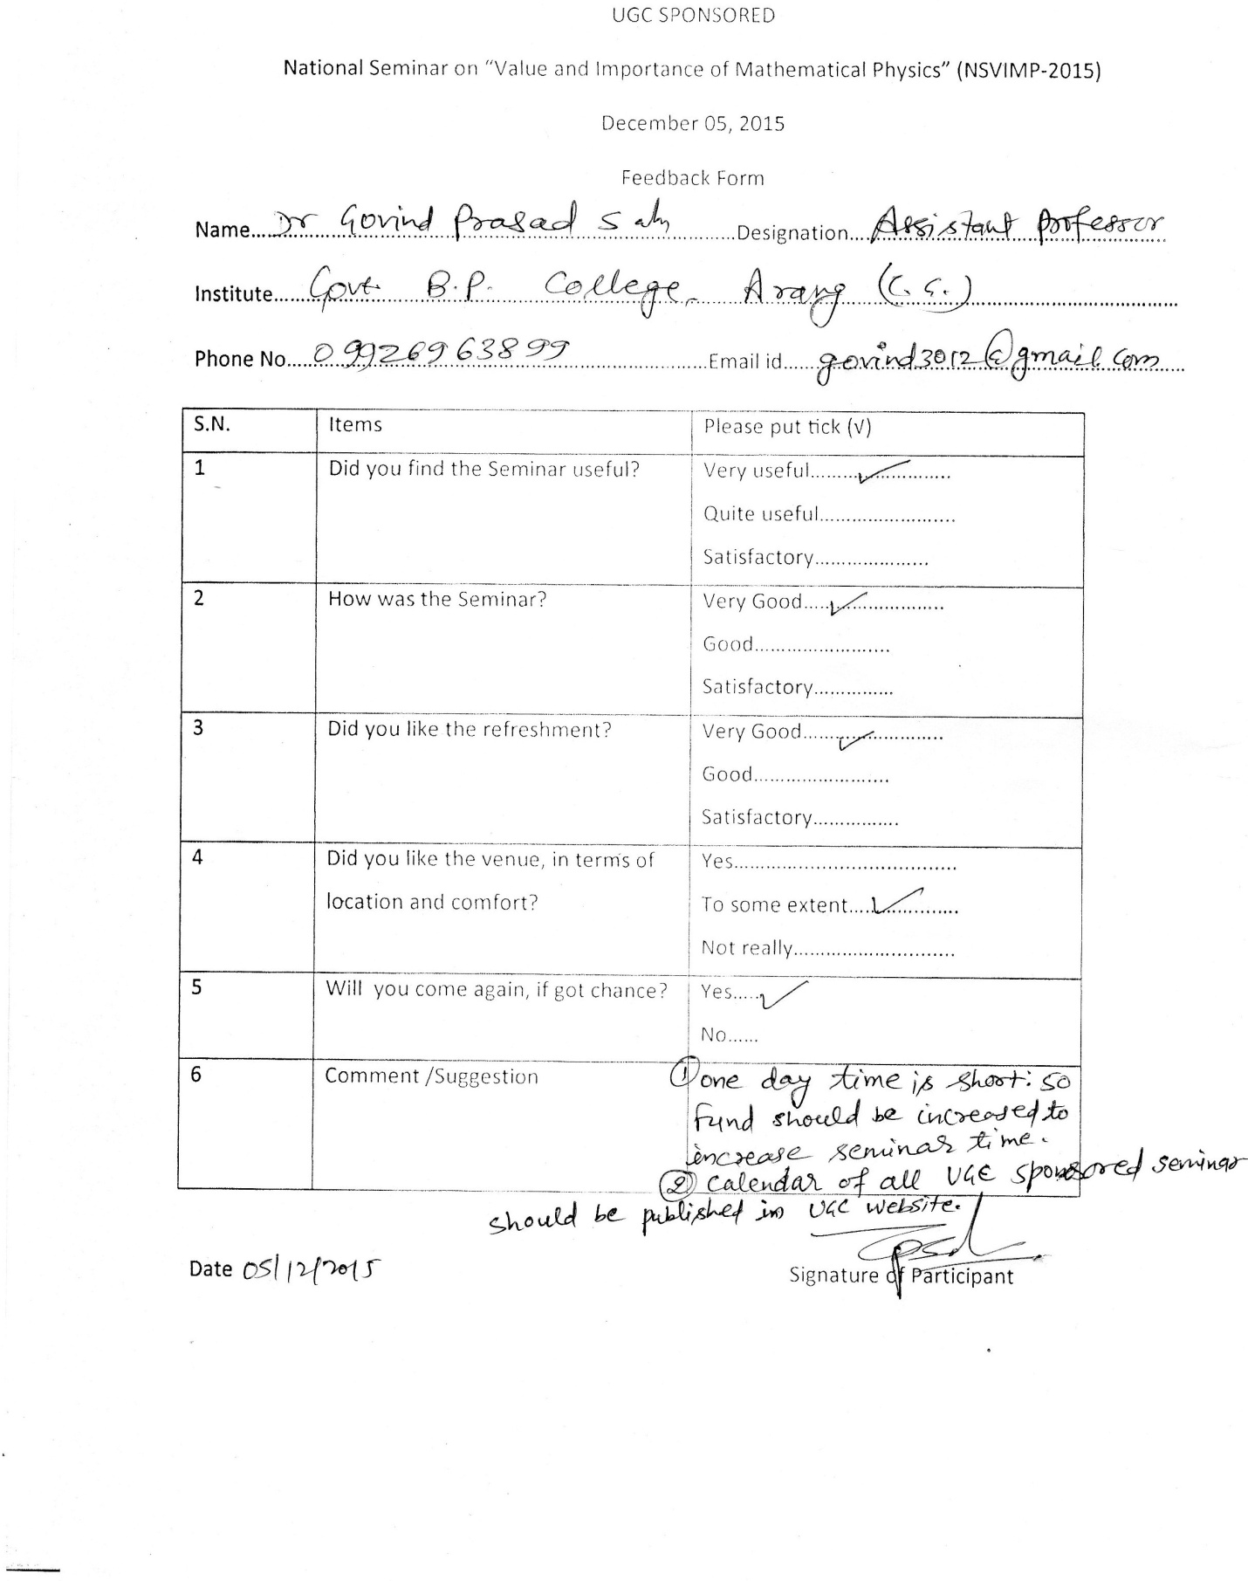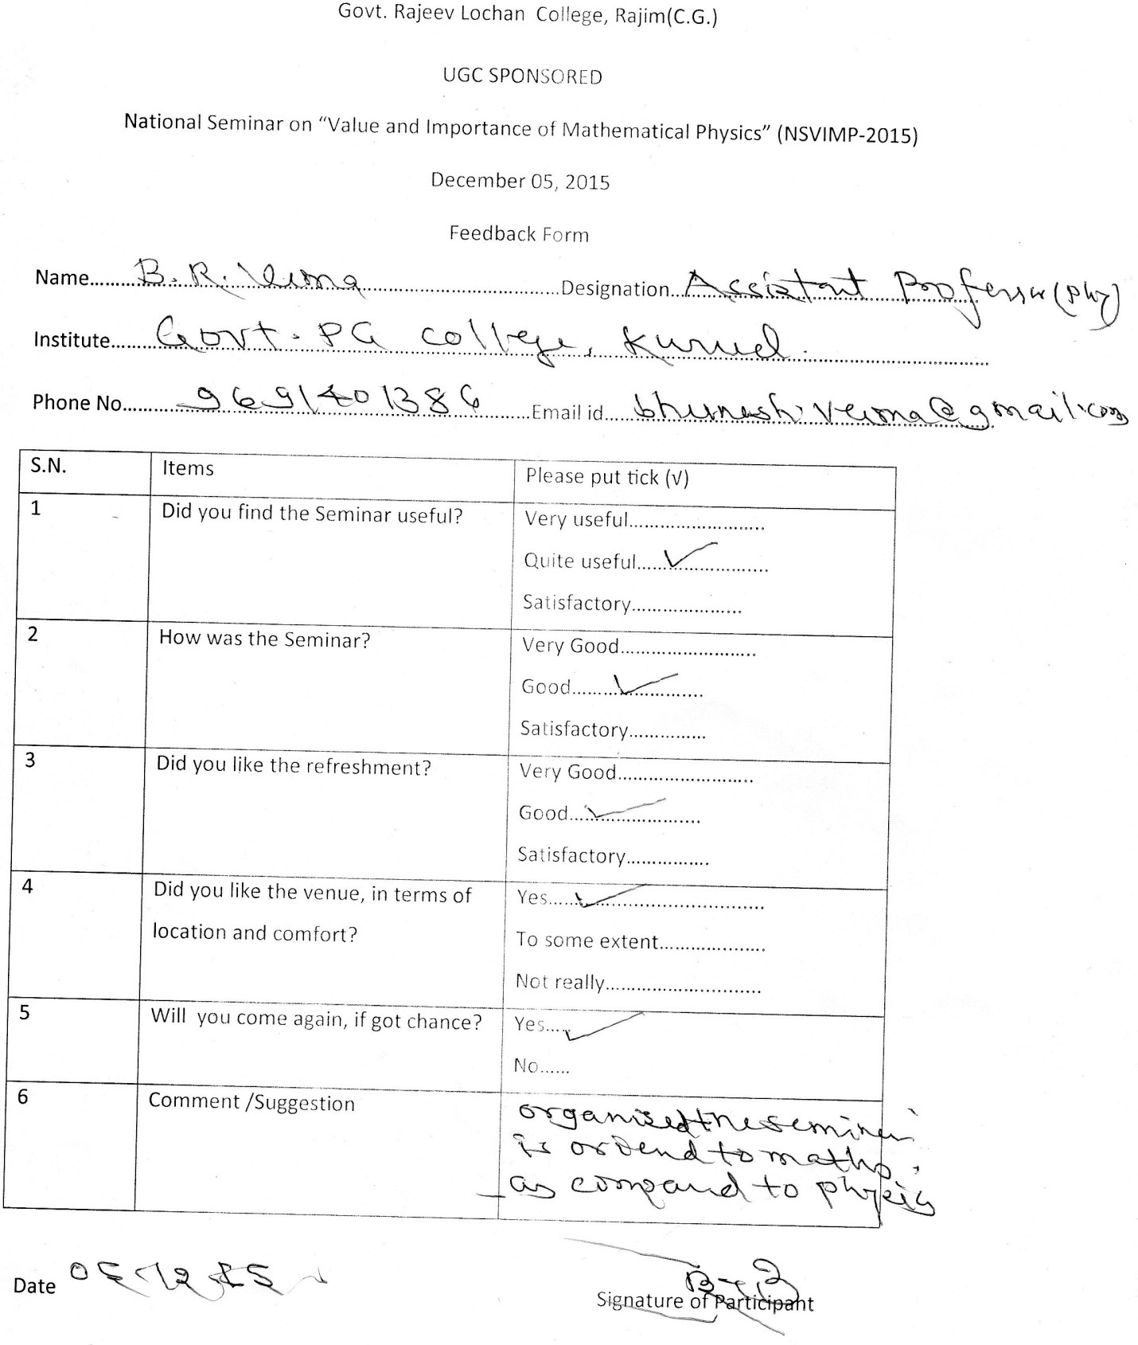

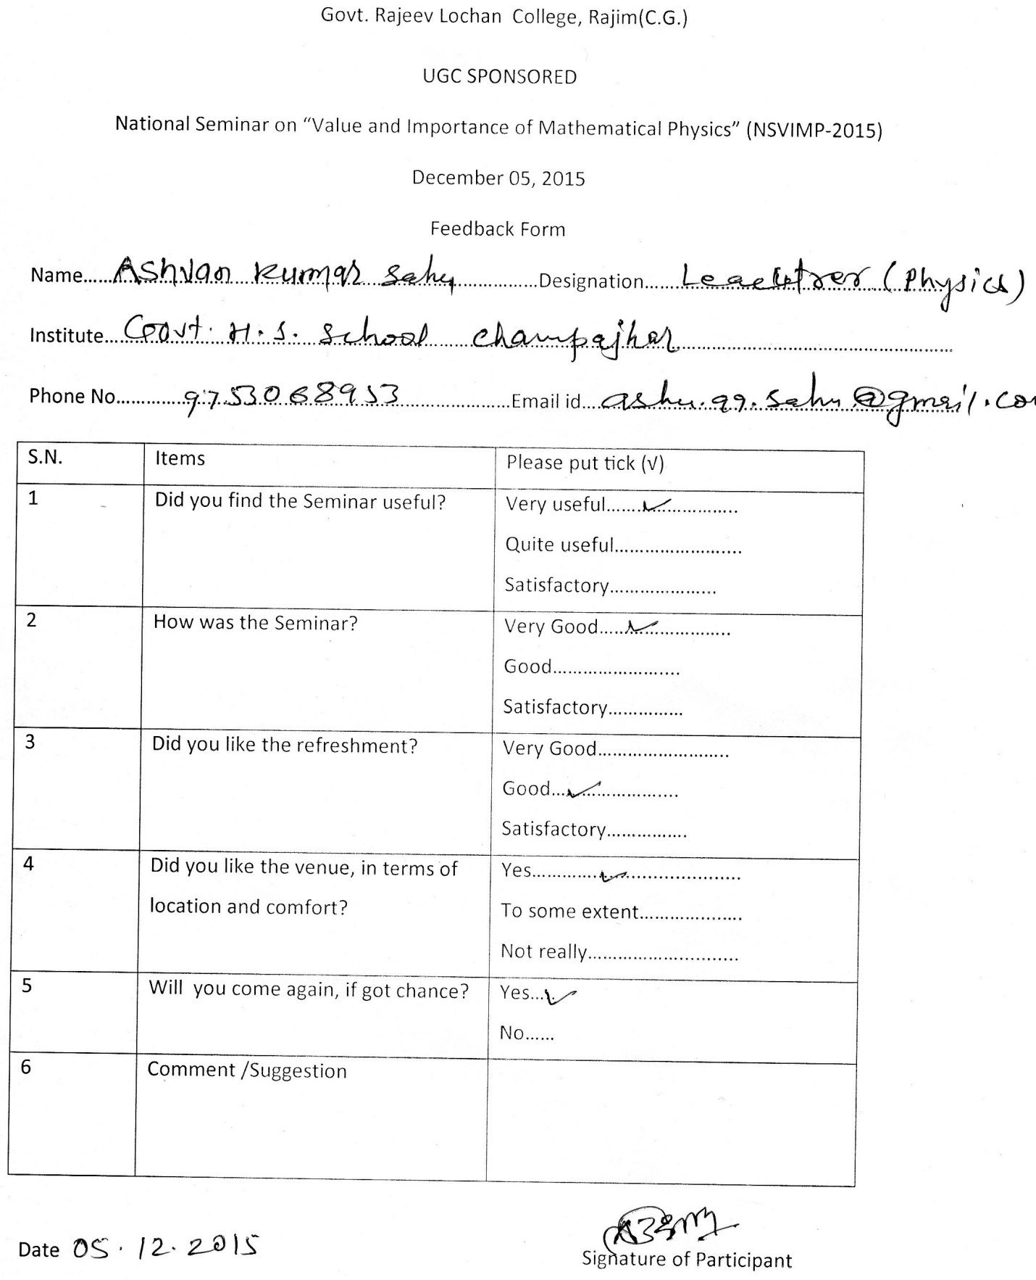
FEEDBACK FORM
1) UGC File No & Date of Sanction Letter: SCW-6/202063/XII/14-15/CRO
a) Amount sanctioned: Rs.77,500=00
b) Amount released: Rs. 62,000=00
2) Name of the Organizing Secretaries:
Dr. Niyati Gurudwan, Assistant Professor (Mathematics)
Prof. Goverdhan Yadu, Assistant Professor (Physics)
3) Name and Address of the College:
Govt. Rajeev Lochan College Rajim, Dist. Gariaband (C.G.) 493885
4) Name of the Collaborating Organization: Nil
5) Title of the Activity:
National Seminar on “Value and Importance of Mathematical Physics”
6) Date: 05 December 2015
7) Venue: Govt. Rajeev Lochan College Rajim, Dist. Gariaband (C.G.) 493885
8) Total numbers of participants proposed and actually attended:
Proposed: 100
Attended: 150
9) Total no. of papers presented (with title):
S.N. | Paper presenter | Institute | Title of the paper
1 | Kailash Dewangan | Dept. of Mathematics, Govt. Digvijay P.G. College, Rajnandgaon | Convergence of Iterative Scheme for Common Fixed Point of Phi-Strongly Hemicontractive and Nonexpansive Operator in Hilbert Space
2 | B.B.Chaturvedi, B.K.Gupta | Dept. of Pure and Applied Mathematics, G.G.U., Bilaspur | Study of time dependent cosmological term in a six dimensional cosmological model
3 | Ishwar Prasad Sahu, D.P.Bisen, N.Brahme, Raunak Kumar Tamrakar | S.O.S. in Physics & Astro Physics, Pt.R.S.U., Raipur | Mechanoluminescence Properties of Europium Doped Strontium Magnesium Silicate Phosphor by Solid State Reaction Method
4 | B.R.Verma | Dept. of Physics, Govt. P.G. College, Kurud | Triboluminescence Produced during Motion of Mercury on Glass Coated with Luminescent Materials
5 | Rishi Jaiswal, Lekhram Sahu, R.S.Singh,R.N.Baghel | S.O.S. in Physics & Astro Physics, Pt.R.S.U., Raipur | Recombination Efficiency in Bilayer Organic Light Emitting Diodes
6 | S.K.Patel | Dept. of Physics, Govt. Digvijay P.G. College, Rajnandgaon | An Analytical Study of Brownian Motion
7 | D.S.Singh | Dept. of Pure and Applied Mathematics, G.G.U., Bilaspur | Generalizations of N-Injective Modules
8 | Abhay Singh | Dept. of Pure and Applied Mathematics, G.G.U., Bilaspur | On Semi - Symmetric Projective Connection
9 | Gurpreet Kour Chhabra, Naseem Bano, Sumita Singh | Chhattisgarh Vanijaya Avam Vigyan Mahavidyalaya, Bhilai | A Study of Numerical Analysis of Computing Mathematics
10 | Govind Prasad Sahu, Joydip Dhar | Dept. of Mathematics, Govt. B.P. College of Arts, Commerce & Science, Arang | Dynamics of an SEIRVS epidemic model with pre-existing immunity, imperfect vaccine and media coverage
11 | Sumita Singh, Vidha Chopade, Asha Rani | Chhattisgarh Vanijaya Avam Vigyan Mahavidyalaya, Bhilai | Change in Education Through Trends in Mathematics
12 | Shabnam Khan | Dept. of Mathematics, Govt. Digvijay P.G. College, Rajnandgaon | Existence of Common Fixed Action Research in Mathematics
13 | Shalini Verma | Bhilai Maitri College, Bhilai | Existence of Common Fixed point under Compatible Maps
14 | Anoop Pandey, Abhishek Bajpai | Dept. of Physics, Govt. D. P.G. College, Dantewada, | Structure Stability and superhalogen properties of FeFn complexes
15 | Goverdhan Yadu, Niyati Gurudwan | Dept. of Physics & Mathematics, Govt. R.L.College, Rajim | Mathematical Approach to Thermo-dynamical System
16 | Hemlal Sahu | Govt. Danteshwari P.G.College, Dantewada | Quantum Cryptography: Future of cryptography
17 | Jyotsana Das, G.S.Das | Govt. H.S. School, Malgaon; Govt. R.L.College, Rajim | Mathematical Studies on Fundamental Quantum Mechanics
18 | K.K.Pathak, Goverdhan Yadu, Mimi Akash Pateria, Kusumanjali Deshmukh, Piyush Jha | Dept. of Applied Physics, R.I.T., Raipur | Comparative studies on optical properties of CdSe, CdSe:Ag and CdSe:Mn nanocrystalline thin film
19 | Piyush Jha | Dept. of Applied Physics, R.I.T., Raipur | Fracto-mechanoluminescence sensing of the fragmentations produced during slow deformation and impact on brittle solids
20 | B.D.Chandak, Goverdhan Yadu, Mimi Akash Pateria | Dept. of Physics, Govt College, Narayanpur | Studies on Photoconductivity parameter of ZnS Semiconducting thin film using Mathematical concept
21 | Ajay Sharma, M.R.Yadav | Dept. of Mathematics, Seth P.C.Agrawal College, Nawapara | Best proximity point theorems for α-rational  cyclic contraction
22 | Shailesh Dhar Diwan | Department of Mathematics, Sant Guru Ghasidas Govt. P.G. College, Kurud | Some common fixed point results for multi-valued mappings satisfying implicit relations in metric spaces
23 | Pankaj Dutta | Department of Physics, Dibrugarh University, Dibrugarh, Assam | Judd Ofelt Theory: a suitable tool to study Rare Earth Spectra
24 | Sriram | Dept. of Astronomy, Osmania University, Hyderabad | Title: Study of period variation in a contact binary system KP113286
25 | Goverdhan Yadu, K.K. Pathak | Govt. Rajeev Lochan College, Rajim C.G. | Studies on Optical, Structural and Photoconductivity properties of Ag2S Semiconducting thin film using Mathematical rule
26 | Suresh Tarak | Govt. H.S.School, Pond, Abhanpur | A comprehensive Mathematical study of Simple Harmonic Oscillator  Suresh Tarak1, Purshottam Verma2, Ashwan Sahu3
27 | Vinod Sahu | Govt. V.Y.T. P.G. College, Durg | Convergence results of iterative scheme for Asymptotically  Quasi-I-Nonexpansive Mappings in Banach spaces
28 | Tejeshwari Thakur | S.O.S. in Mathematics, Pt.R.S.U., Raipur | ID-Based Directed Multi Proxy Chameleon Hash function  and Chameleon Signature Scheme with Pairing
29 | Swati Verma | Govt. V.Y.T. P.G. College, Durg | Improvement of Merkle-Hellman  Scheme using RSA Problem
30 | Anita Gupta | Dept. of Mathematics, C.V.Raman University, Bilaspur | Coupled common fixed point for two pairs of w-compatible maps satisfying rational contractive expression
31 | Khushboo Thakur, B.P. Tripathi | Govt. N.P.G. College of Science Raipur | NTRU Cryptosystem with Jordan  Canonical Form
32 | Dipti Thakur | S.O.S. in Mathematics, Pt.R.S.U. Raipur | A modified S*-iteration process for asymptotically  nonexpansive mappings in a Banach space
33 | Animesh Kumar Sharma, Dr. R.S. Parihar, Dr. C. L. Dewangan | Department of Mathematics, Sunrise University, Alwar, Rajasthan | On Some SIV and RIV fuzzy graphs
34 | Sunita Gupta, Dr. Mini A Pateriya | Department of Applied Physics, CSIT, Durg | Structural, electrical and optical Studies of CuInS2 thin films prepared by CBD method: A review
35 | Nidhi Dewangan | S.G.G. Govt. P.G. College, Kurud | Propagation of surface wave in fluid saturated porous medium sandwiched between magneto-elastic self-reinforced layer and heterogeneous isotropic half-space
36 | S. K. Choubey | Dept. of Pure and Applied Mathematics, G.G.U. | Weak Rad-⊕-supplemented Modules
37 | Shalini Patil | Dept. of Physics, Govt. Autonomous P.G. College, Chhindwara (M.P.) | Importance Of Mathematical Physics
38 | Sangeeta Jha, Ranu Agrawal, Dewanand | Govt. Rajeev Lochan College, Rajim C.G. | Role of Mathematics in Economics
39 | Hemant Kumar Nashine, Atul Kumar Sharma | Department of Mathematics, Anily School of Applied Science Amily University | Coupled fixed point without mixed monotone mappings
40 | Sonia Israni | Govt. Rajeev Lochan College, Rajim | The Importance of using the English Language in Physics and Mathematics
41 | Priyanka Israni | Govt. Rajeev Lochan College, Rajim | The relationship of Chemistry with Physics
42 | Rita Yadav, Madhubala Mishra | Govt. Rajeev Lochan College, Rajim
43 | Rajesh Sriwas, Jeevanlal Gayekwad | Govt. Rajeev Lochan College, Rajim

Invited Talk
S.N. | Title | Name and Designation | Institute
1 | Physics and Mathematics in Biology: A ‘Computational Molecular Biophysics’ Perspective | Navin Chandra, Associate Professor | University Department of Physics, Vinoba Bhave University, Hazaribag, Jharkhand; previously at S. N. Bose National Centre for Basic Sciences, Kolkata
2 | Light Emitting Diodes: A Technical Aspects | B.R.Verma  Assistant Professor | Department of Physics, Government Post Graduate College, Kurud (Dhamtari) (C.G.)
3 | Stationary States of a Quantum System | Sandeep Soni  Assistant Professor | Department of Physics, Govt. G.S.G. P.G. College, Balod (C.G.)
4 | Fractal Geometry: A New Branch of Mathematics | Balwant Singh Thakur  Associate Professor | S.O.S. in Mathematics, Pt. Ravishankar Shukla University, Raipur (C.G.)
5 | Cryptography and Information Security | Dr. Amitabh Banerjee | Principal Govt. S.N. College, Nagri, (C.G.)
6. | The Basics of Mathematical Physics | Goverdhan Yadu  Assistant Professor | Govt. Rajeev Lochan College Rajim (C.G.)

10) Total amount sanctioned: Rs._77500=00
11) Total expenditure incurred in conducting the Activity: 141850=00
12) Grant received from various agencies other than the UGC for this Activity: NIL
13) Details of internal revenue, if any, generated by the Institution/ Department on account of this Activity: Registration Fee -25000=00
14) Briefly mention about the technological/ academic or any other benefit generated by conducting this Activity with respect to a) the institution b) the faculty, c) students, d) industry/ society:
- The seminar created a platform for young researchers in the field of Mathematical Physics to interact with eminent personalities in the respective field. Motivated by this activity around 15 student joined Post graduated courses in the current session.
- In the seminar, persons from different fields exchanged and shared their experiences and research results related to various aspects of Mathematical Physics and discussed the challenges encountered and the solutions adopted, hence enhanced their development and facilitated the emergence of new technologies in our state and country which was very beneficial for the rural student.
- National Seminar on “Value and Importance of Mathematical Physics” was the first attempt in the whole region of Rural Gariaband district that the college organized a national seminar in the field of mathematics and physics. It was a historical moment for the college and the nearby educational institute. This event played an important role for the advancement of academic environment.
- College also gets motivated for organizing such national level programs.
_______________________________ __________________________________:
Organizing Secretary Principal
Dr. Niyati Gurudwan Dr. Priti Tiwari
Prof. Goverdhan Yadu
Place: Rajim
Date:08-12-2015
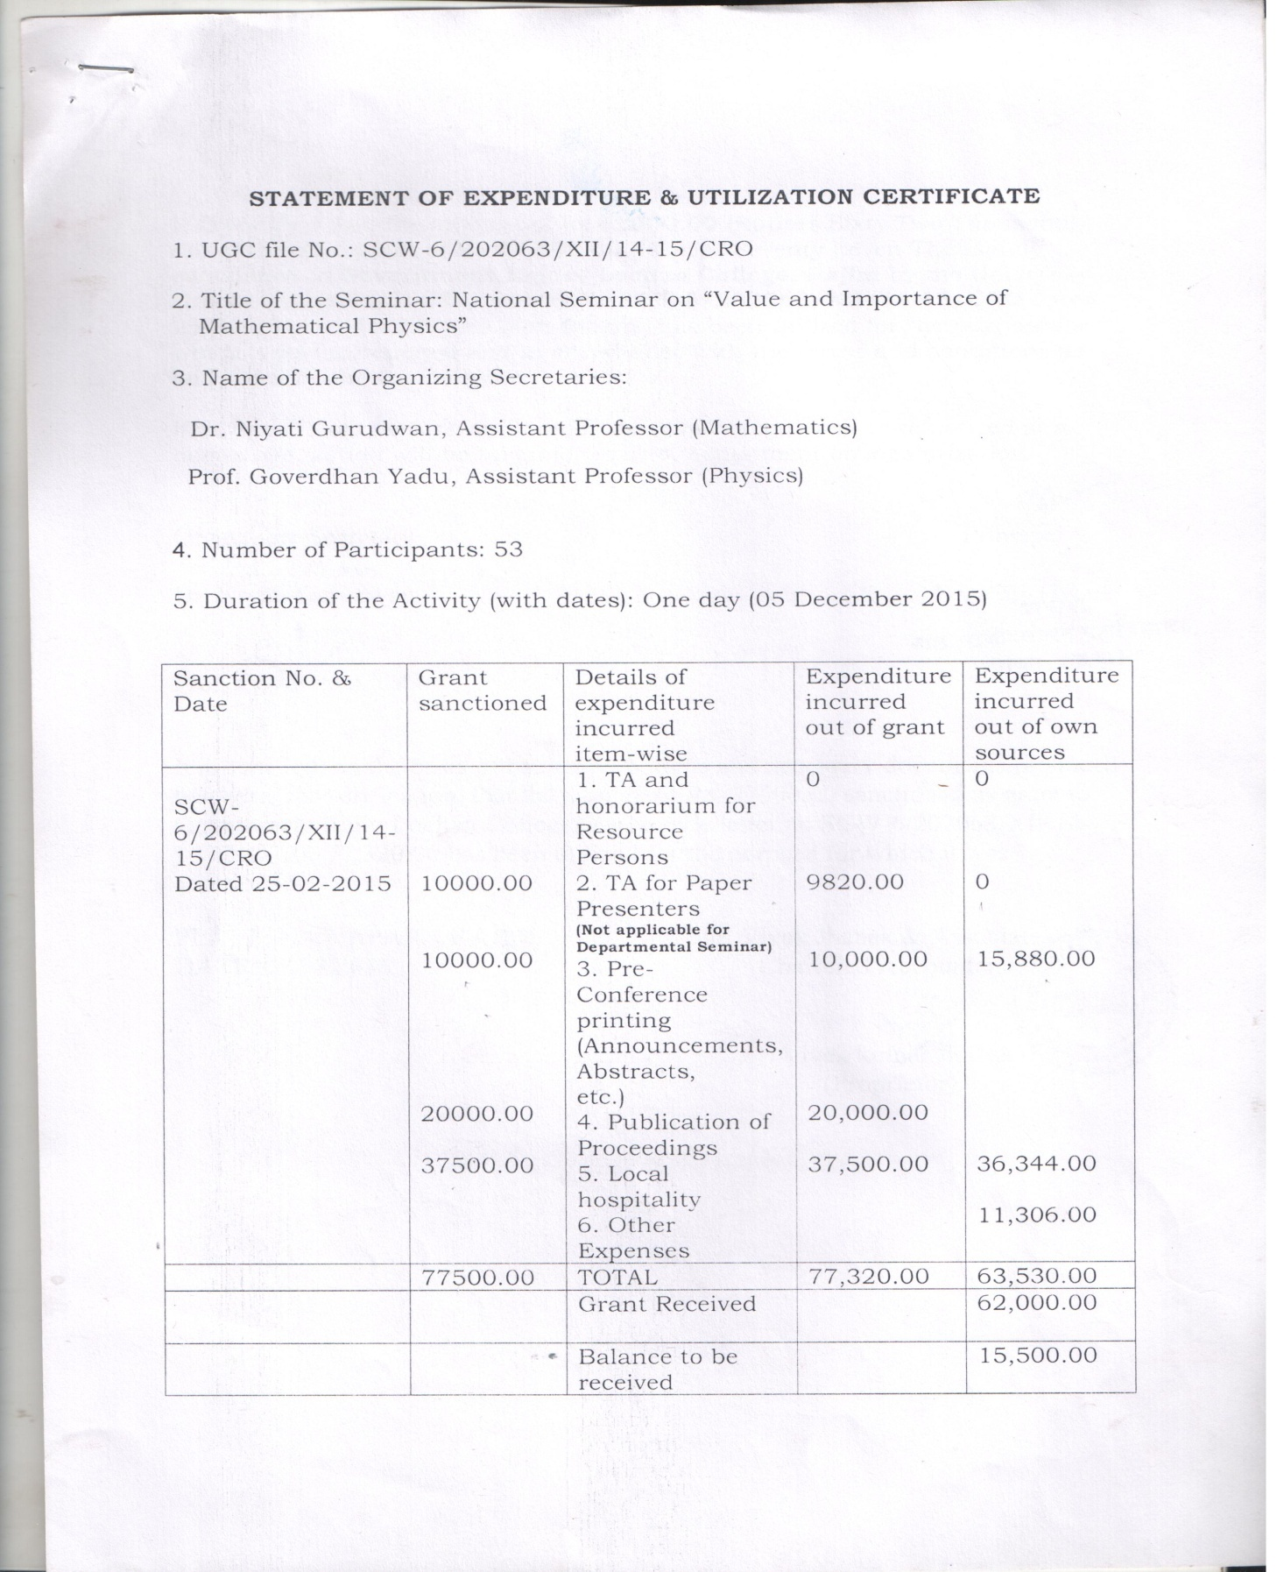
Utilization Certificate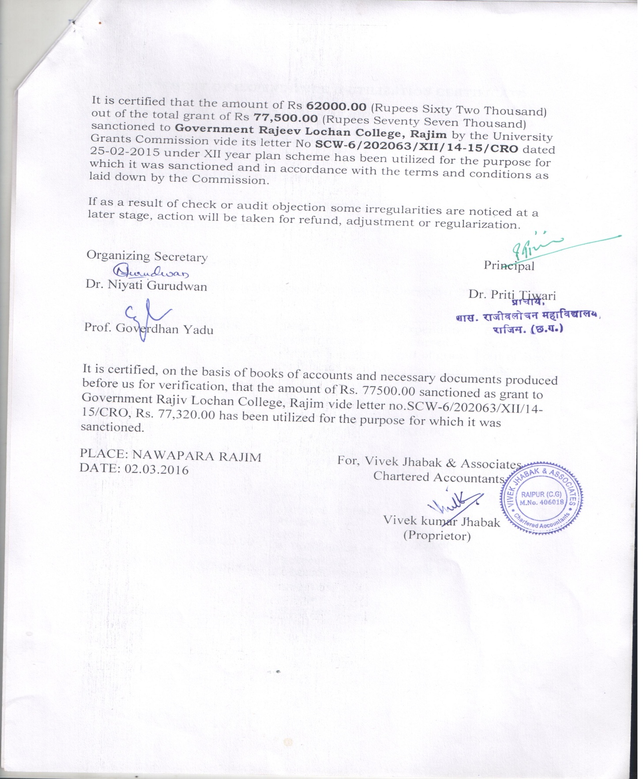
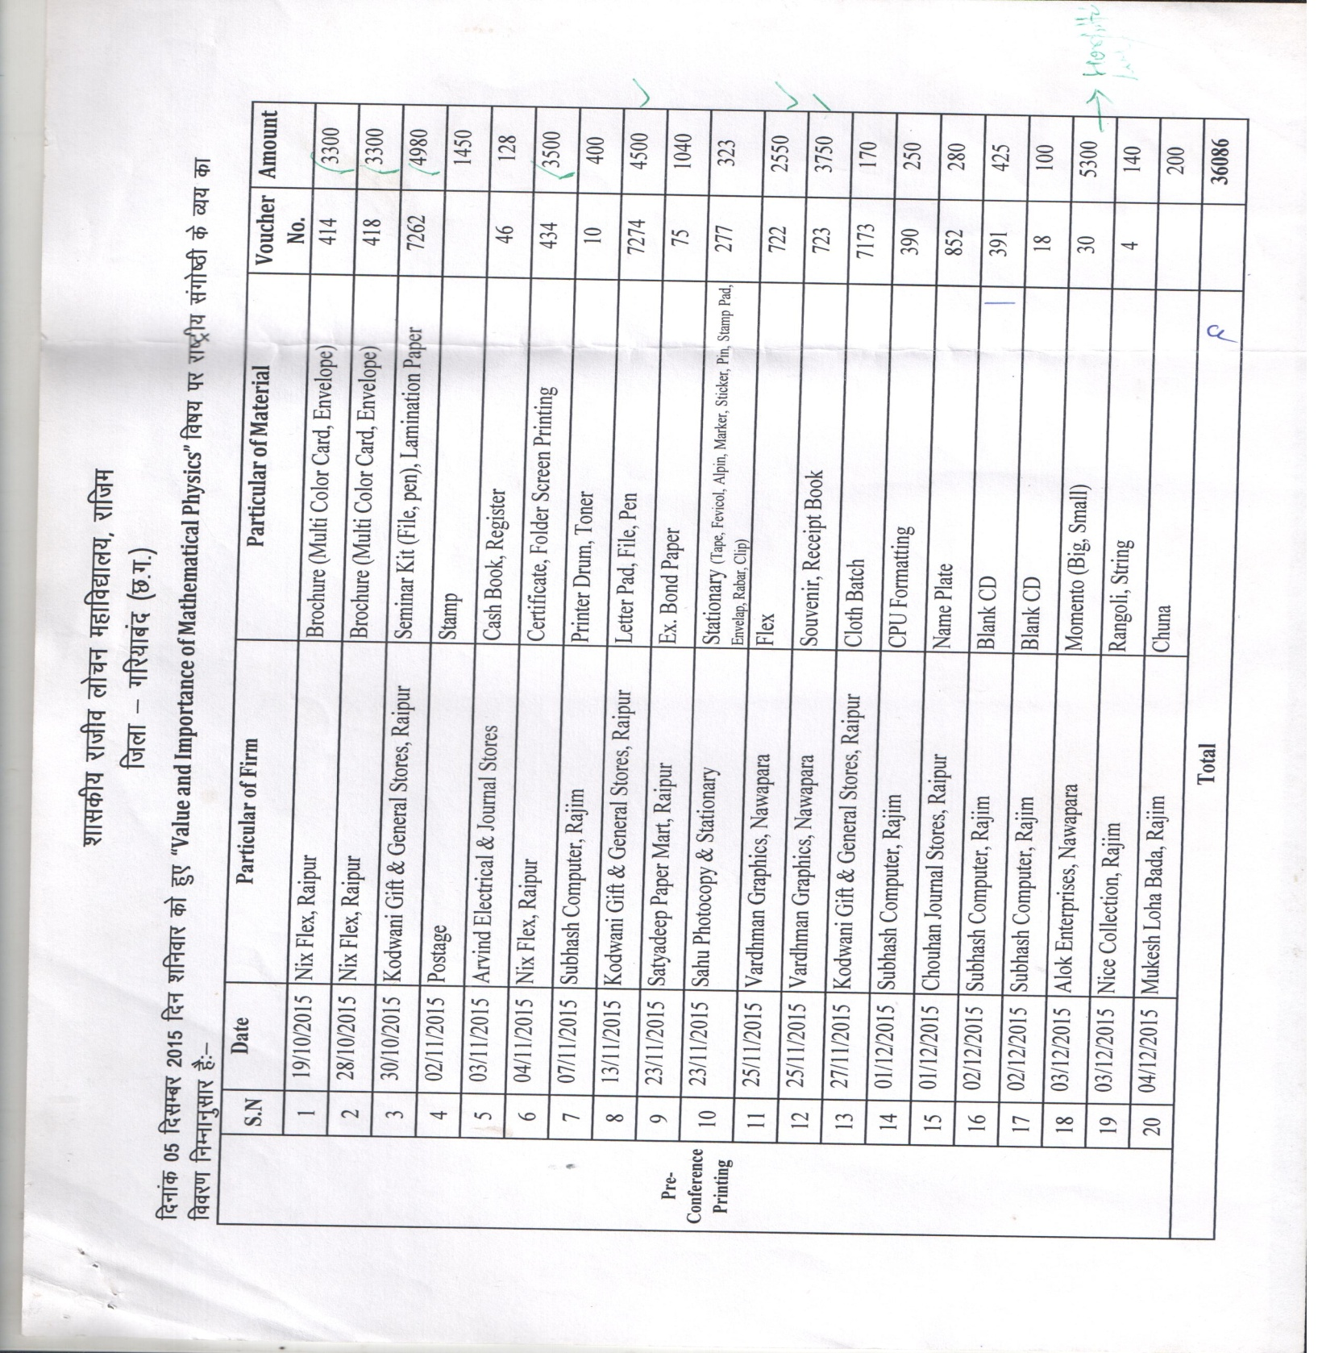
Head wise Bill Details
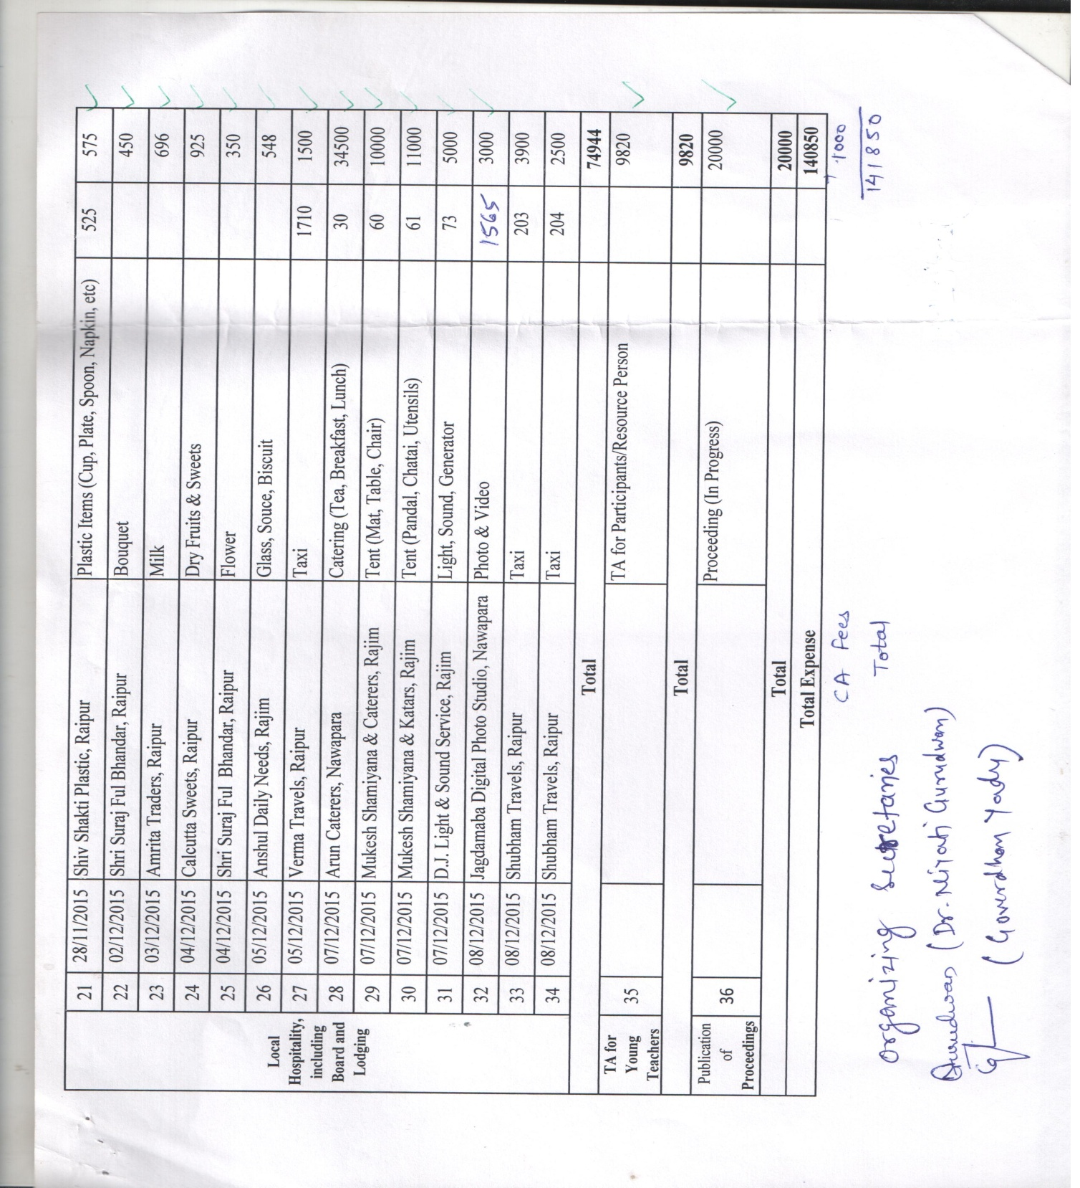
Press Release
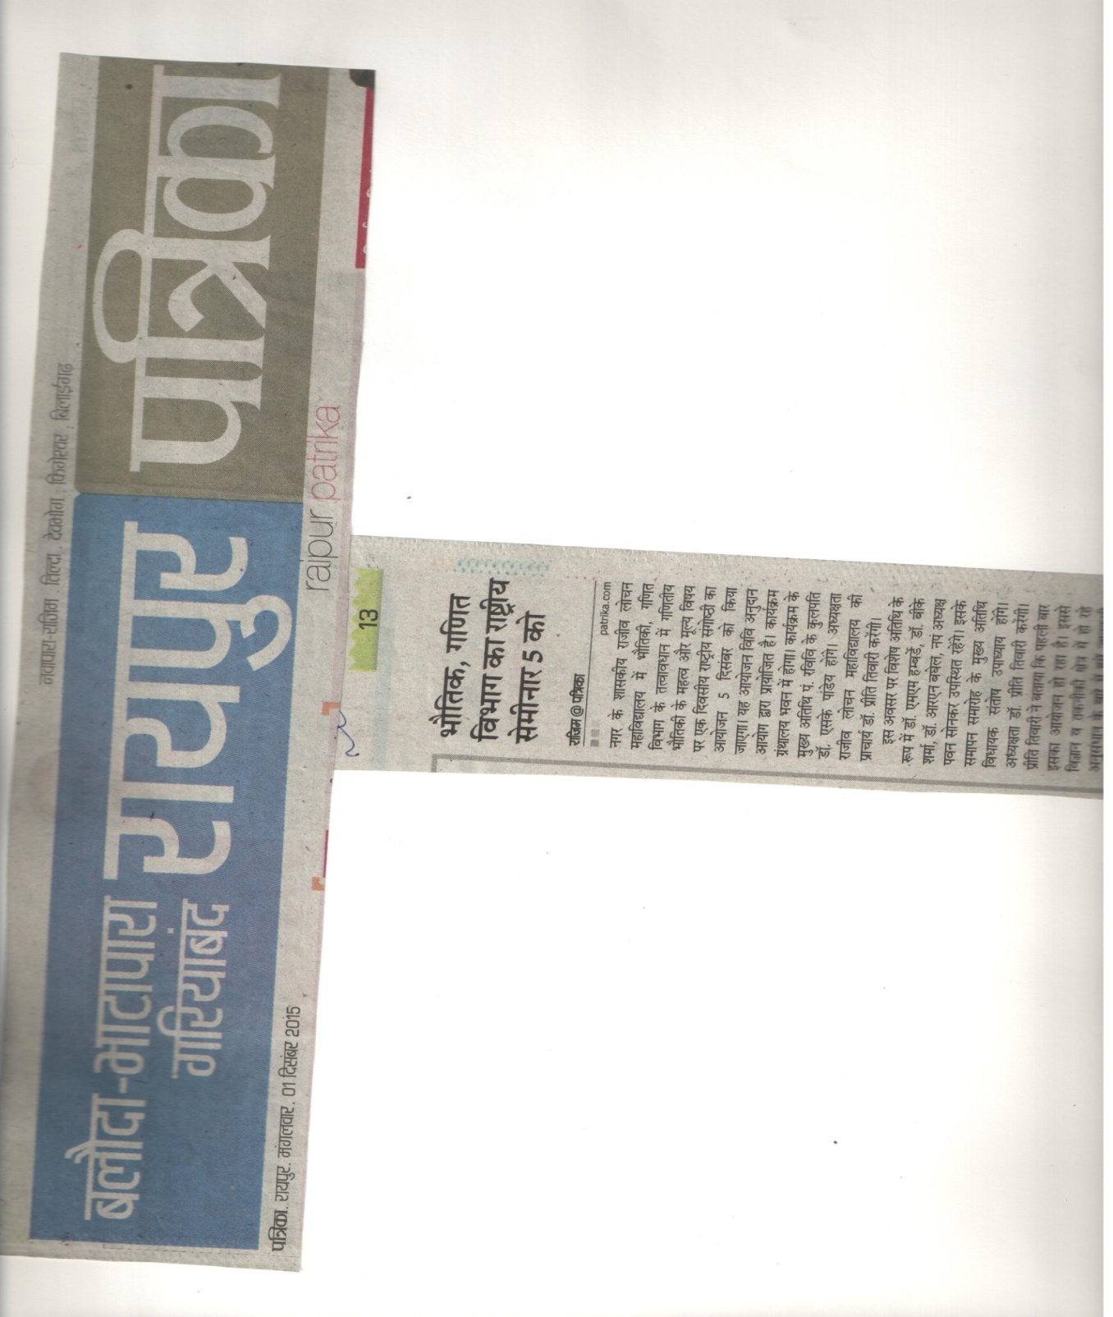

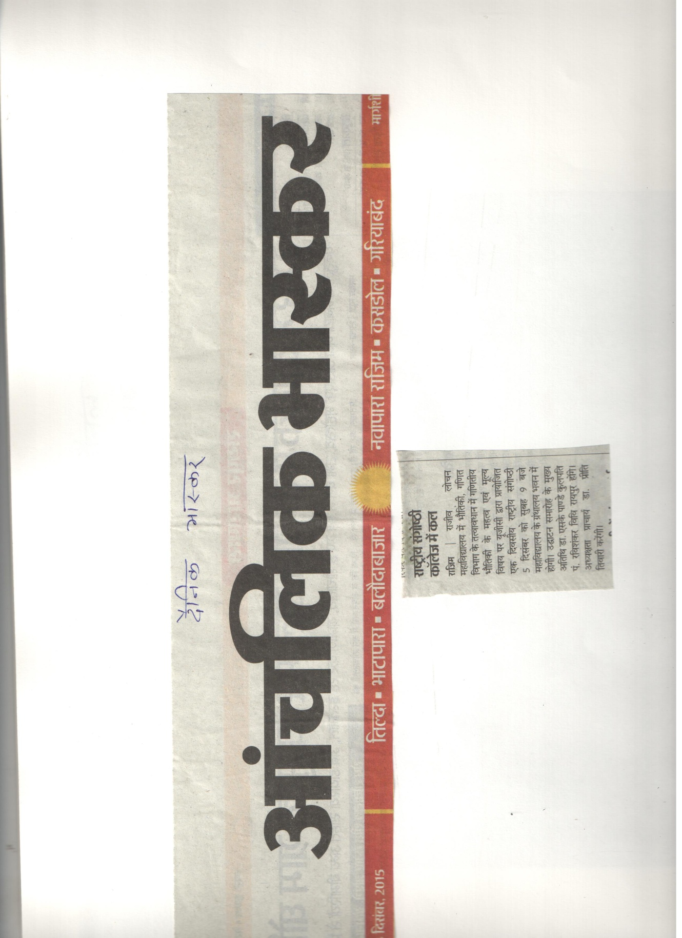
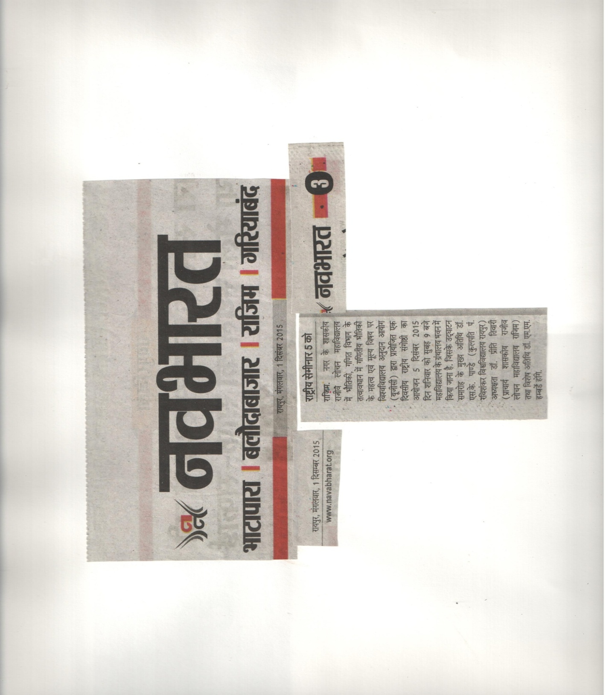

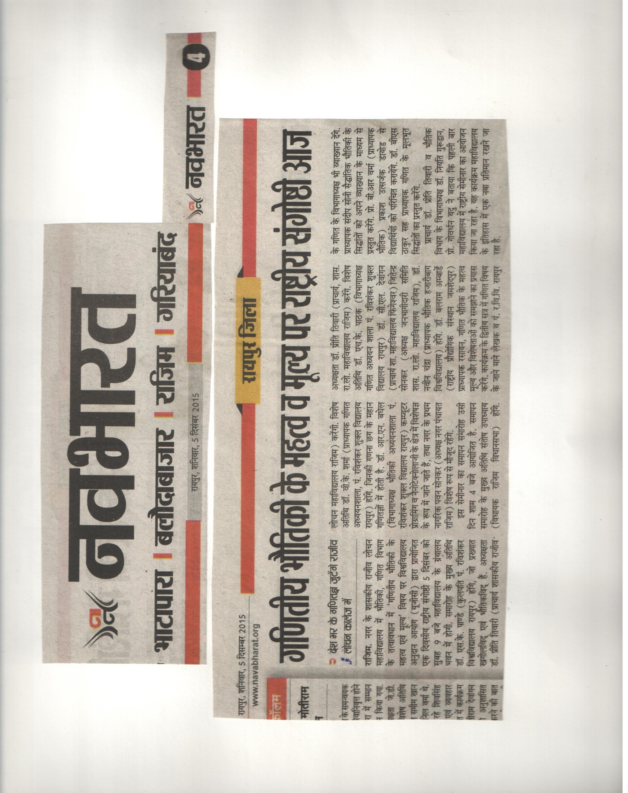
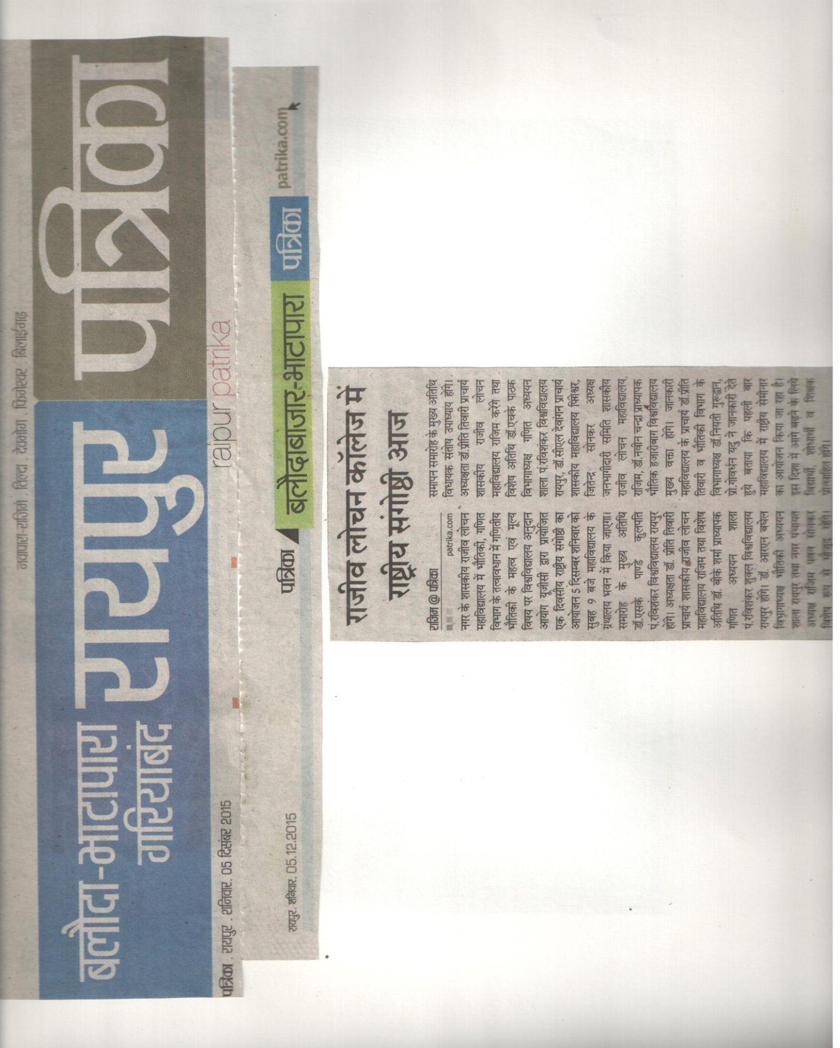

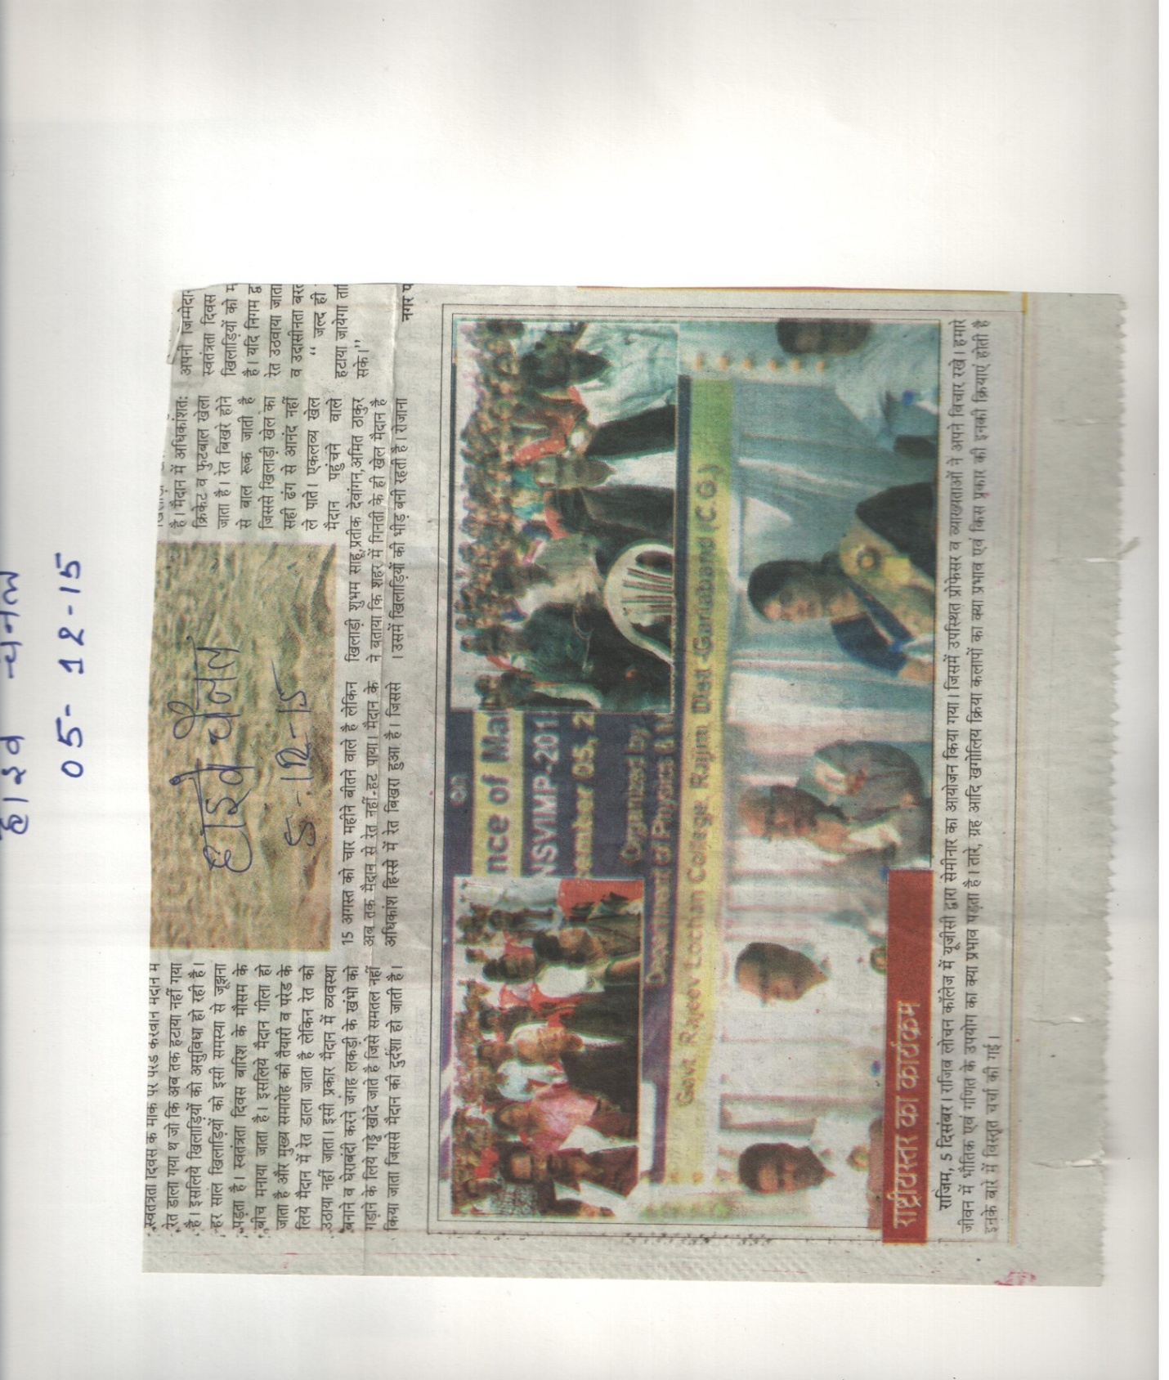
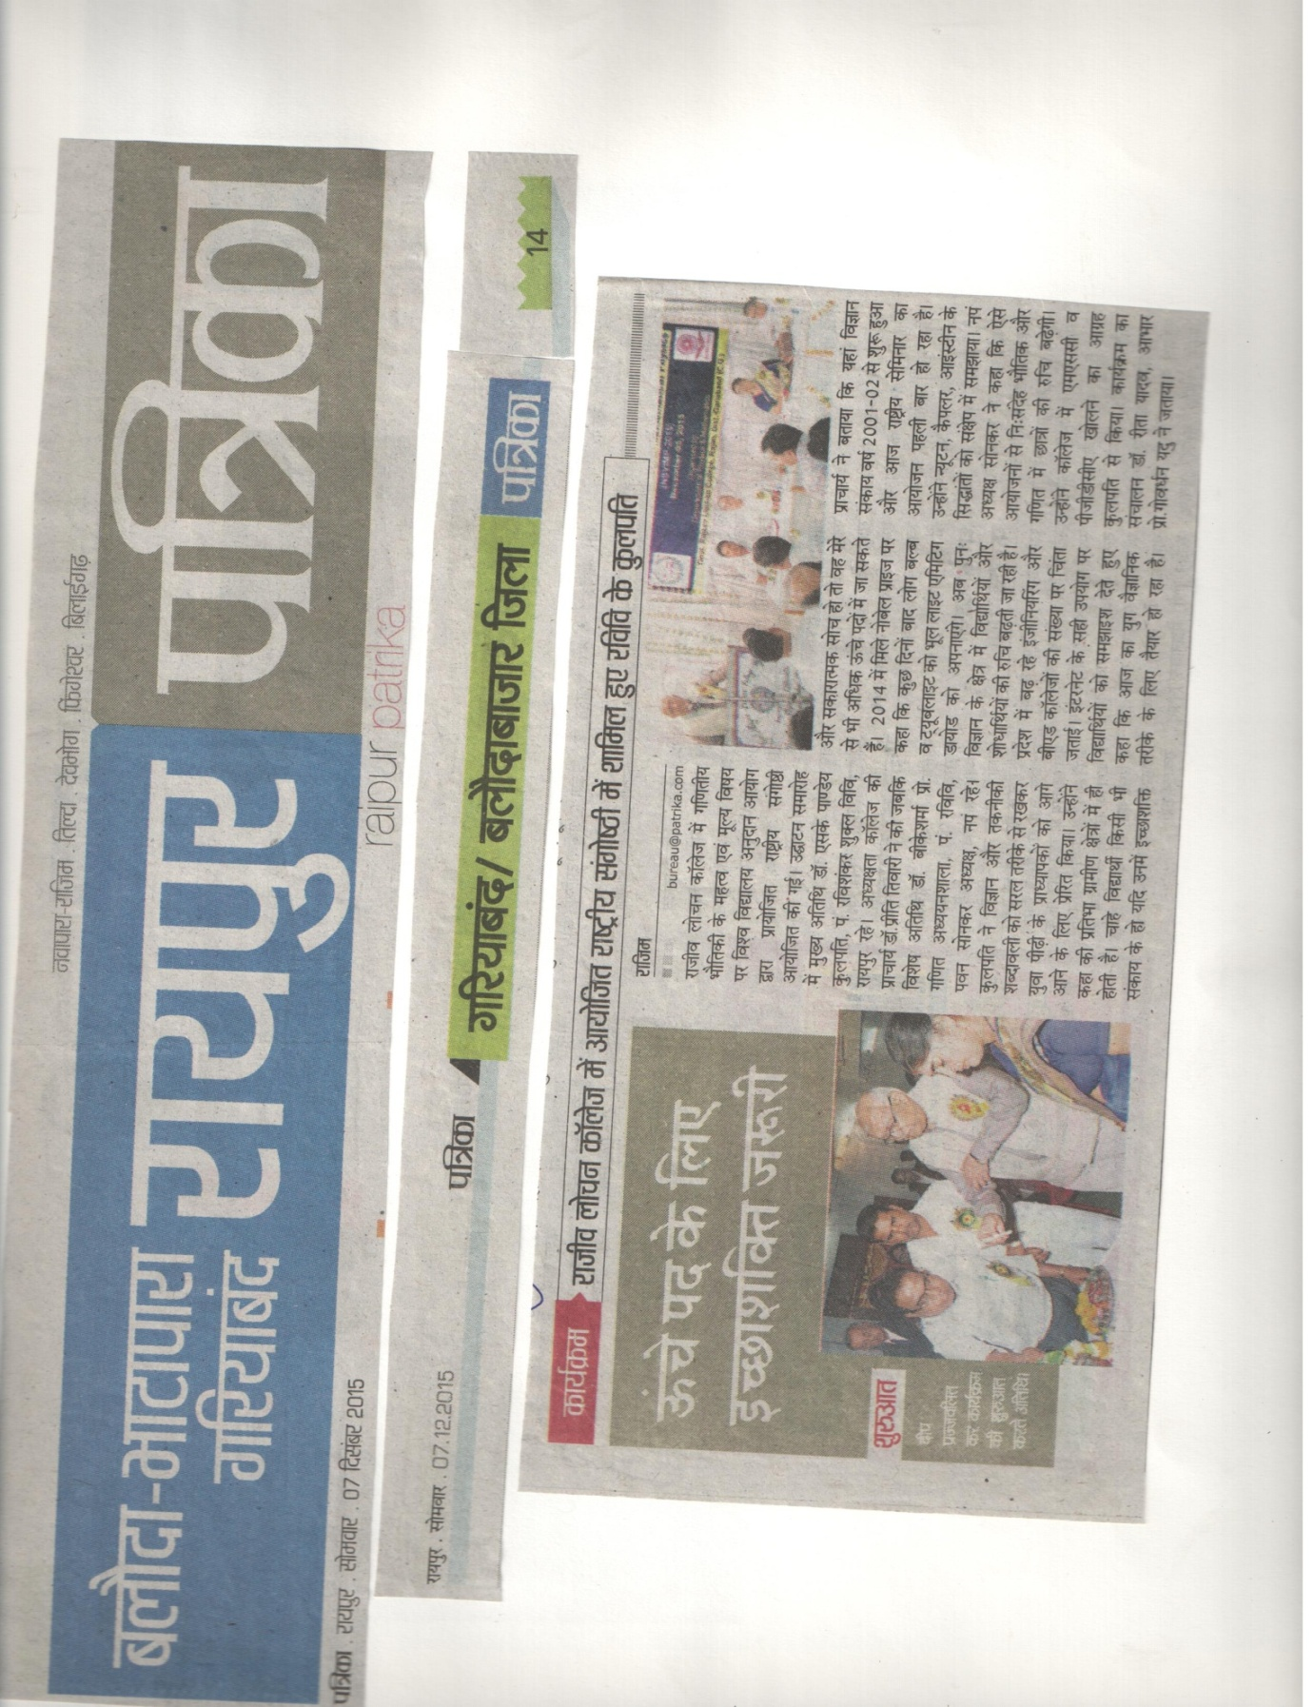
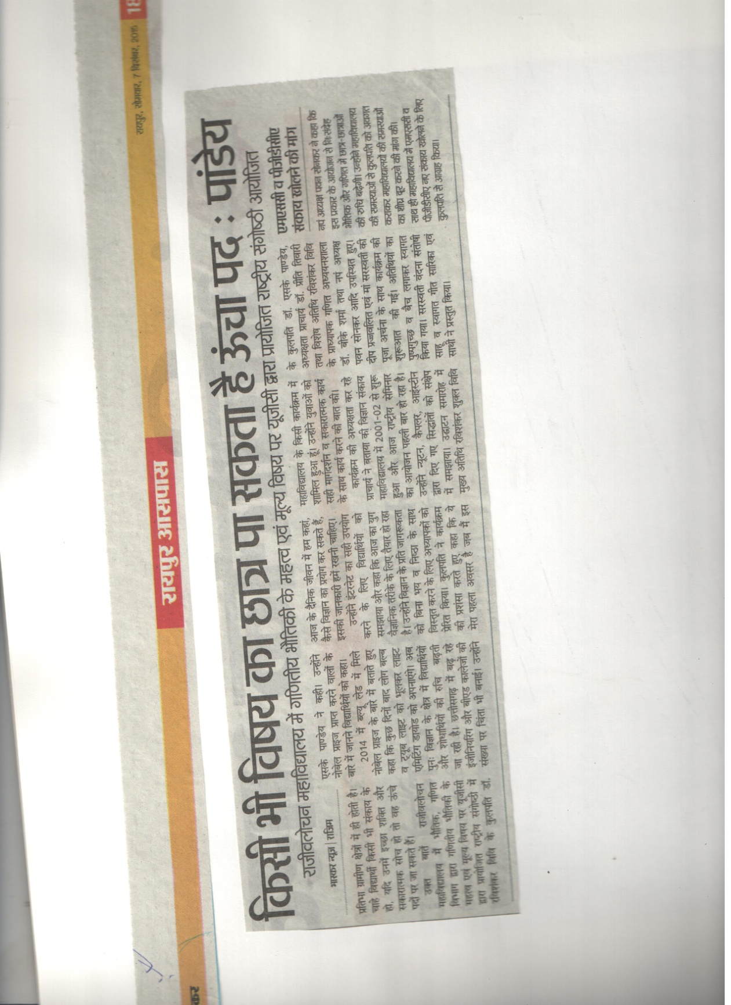

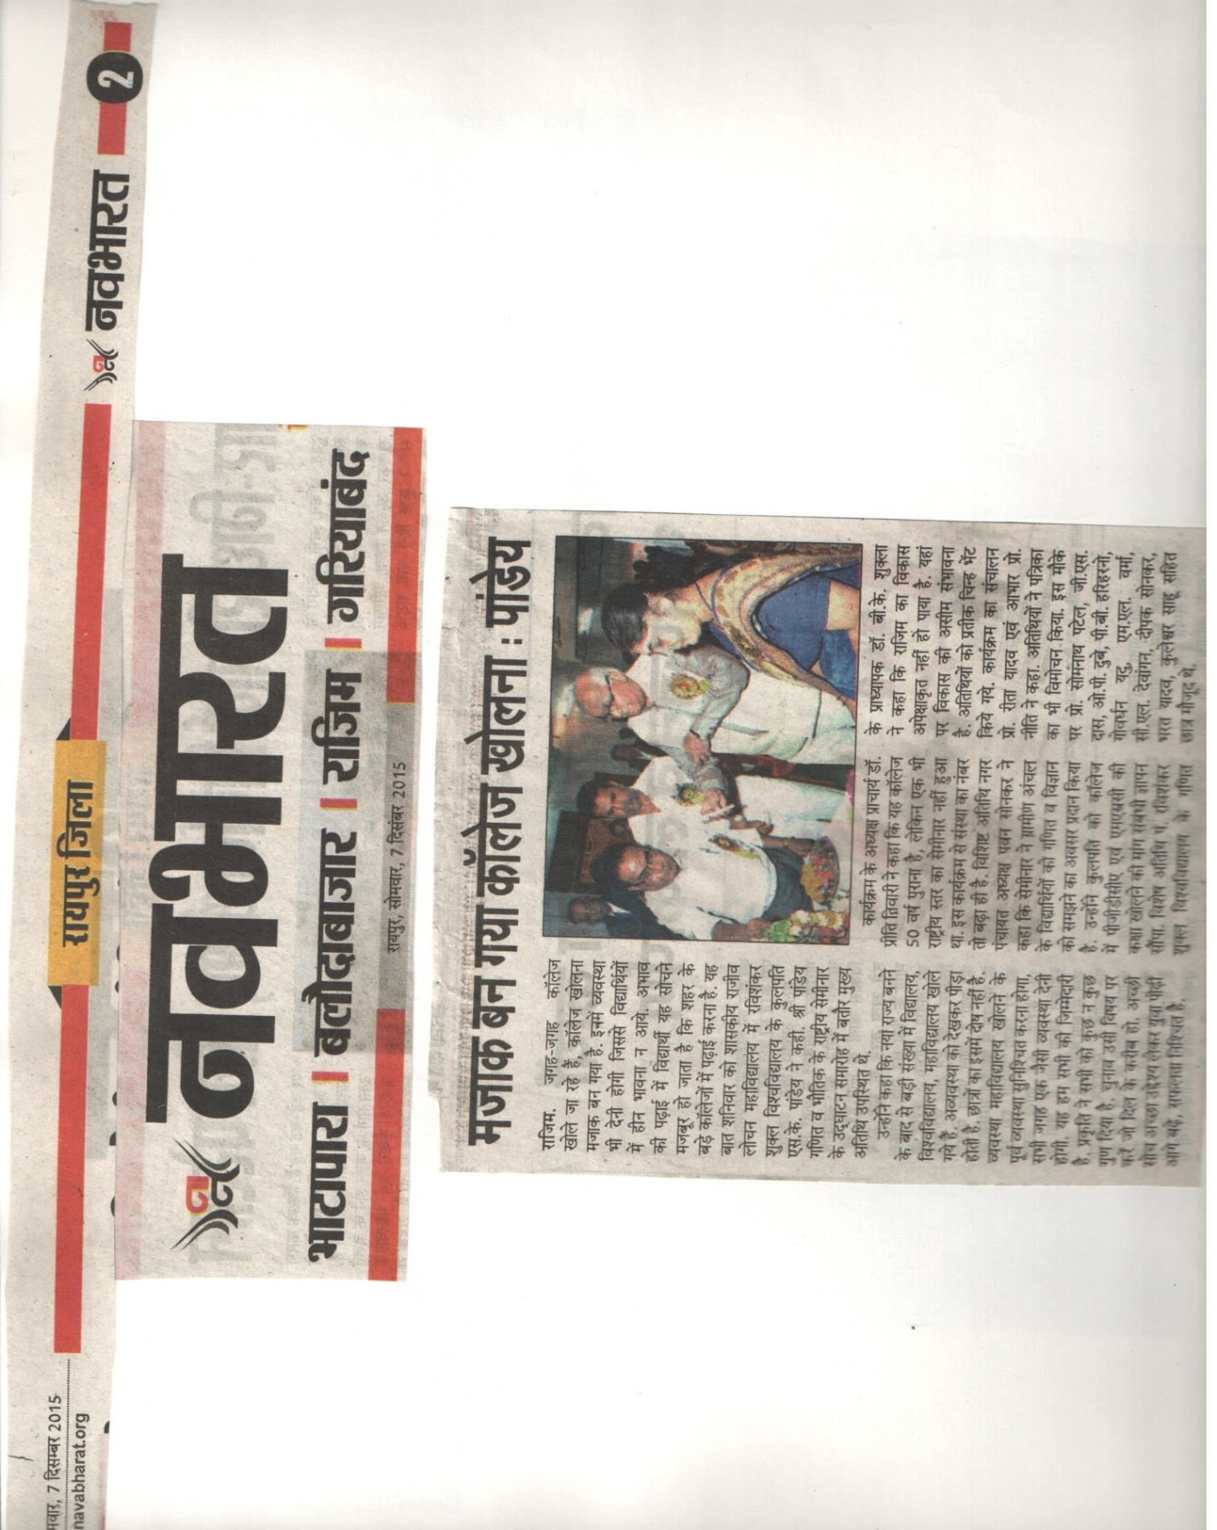

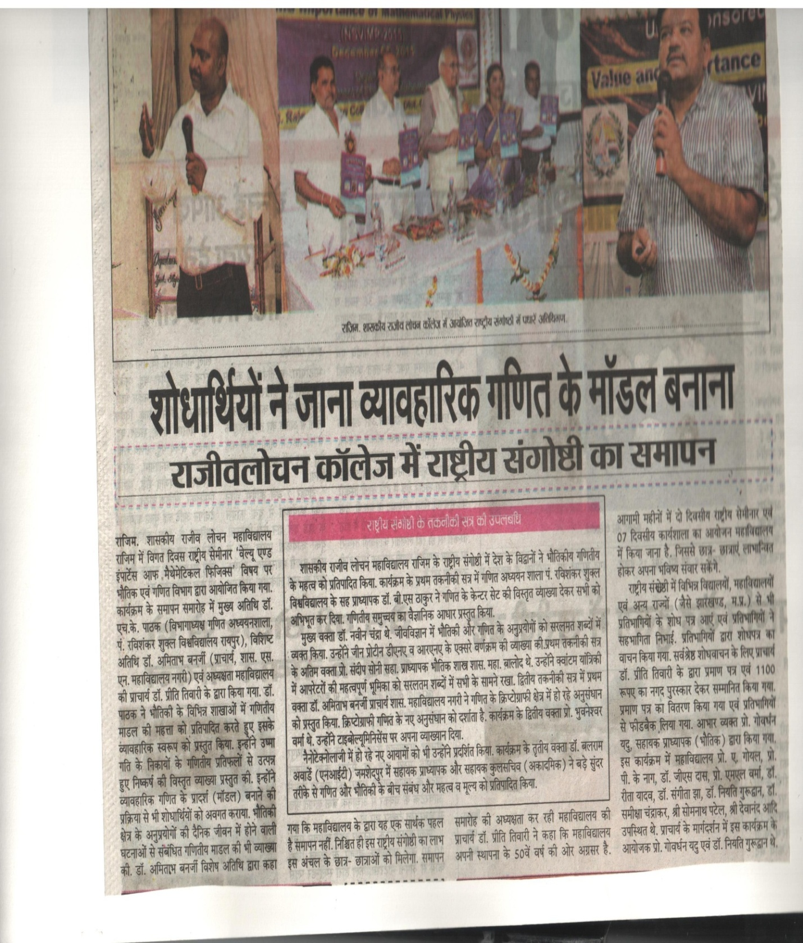
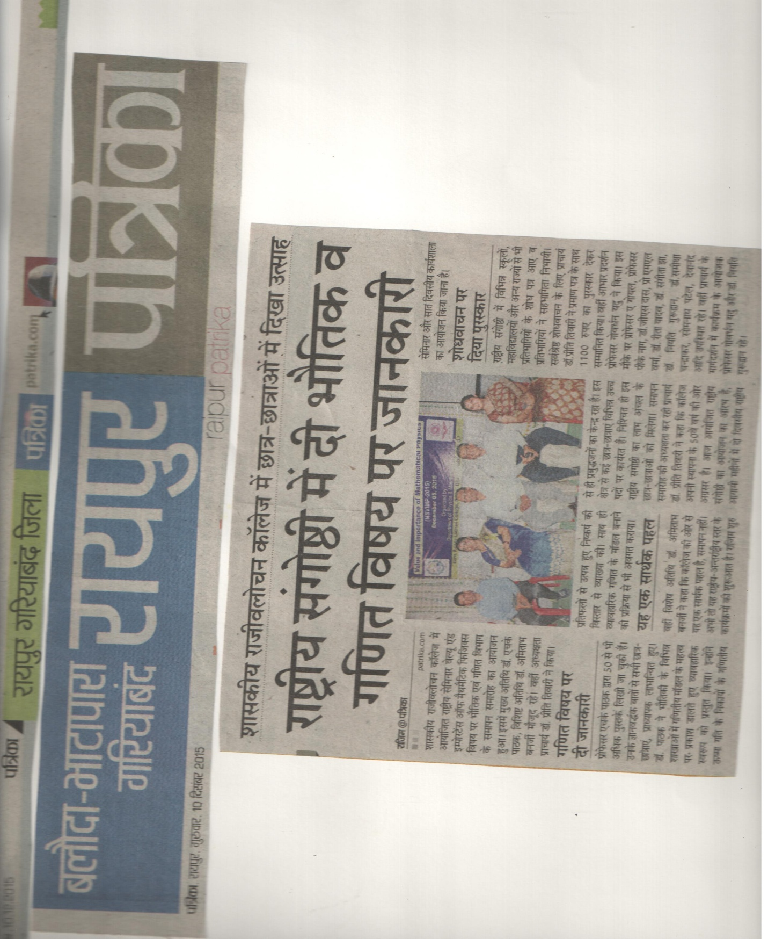
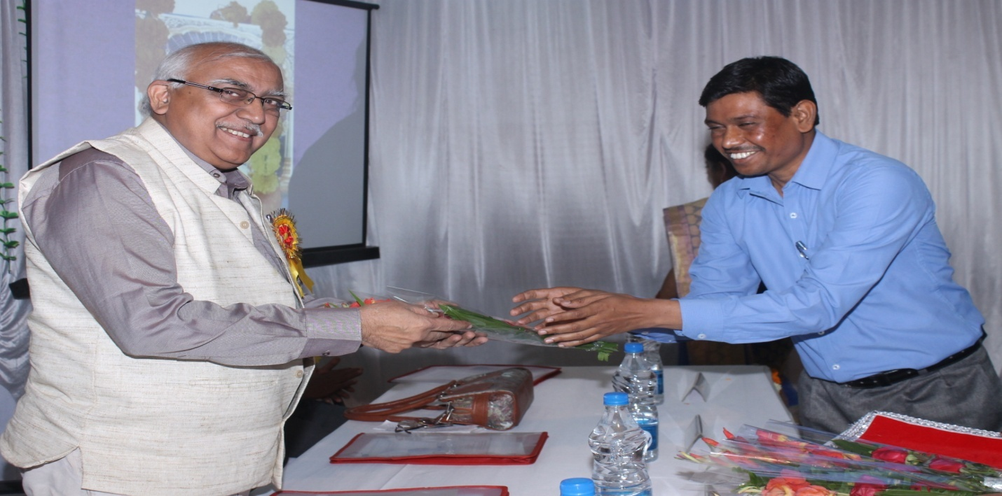
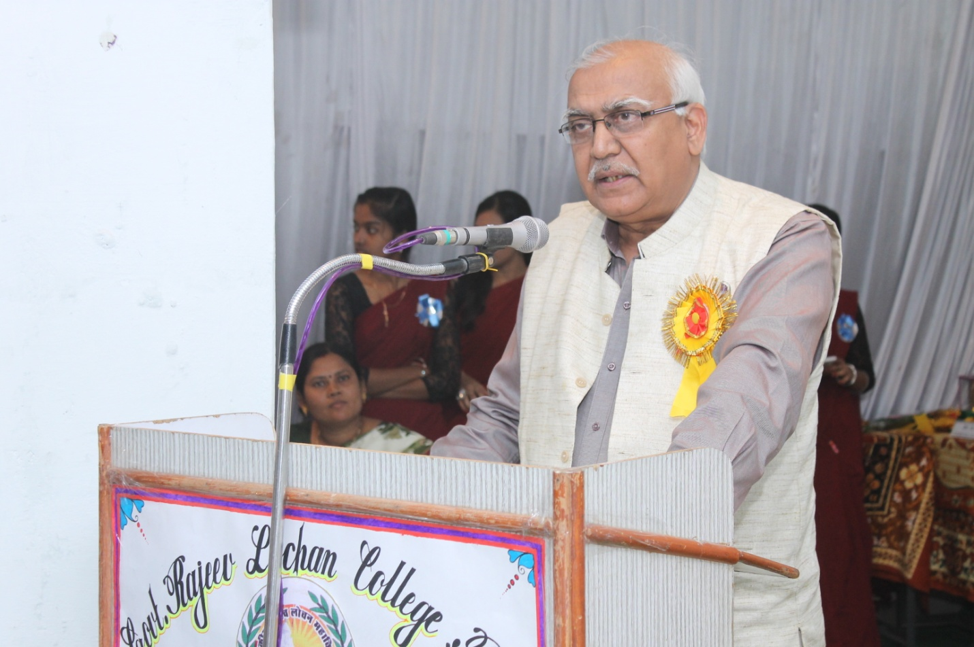

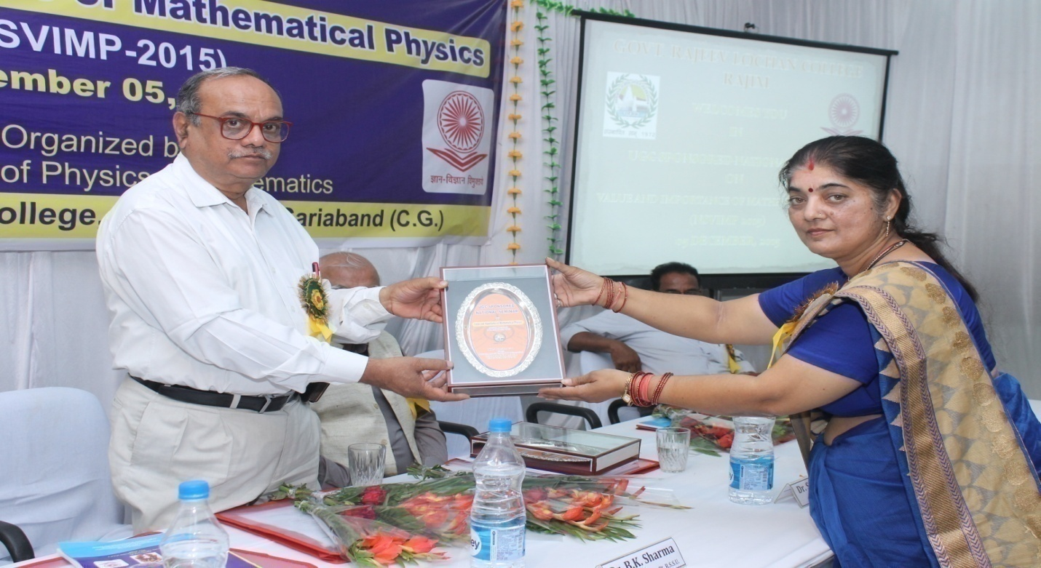

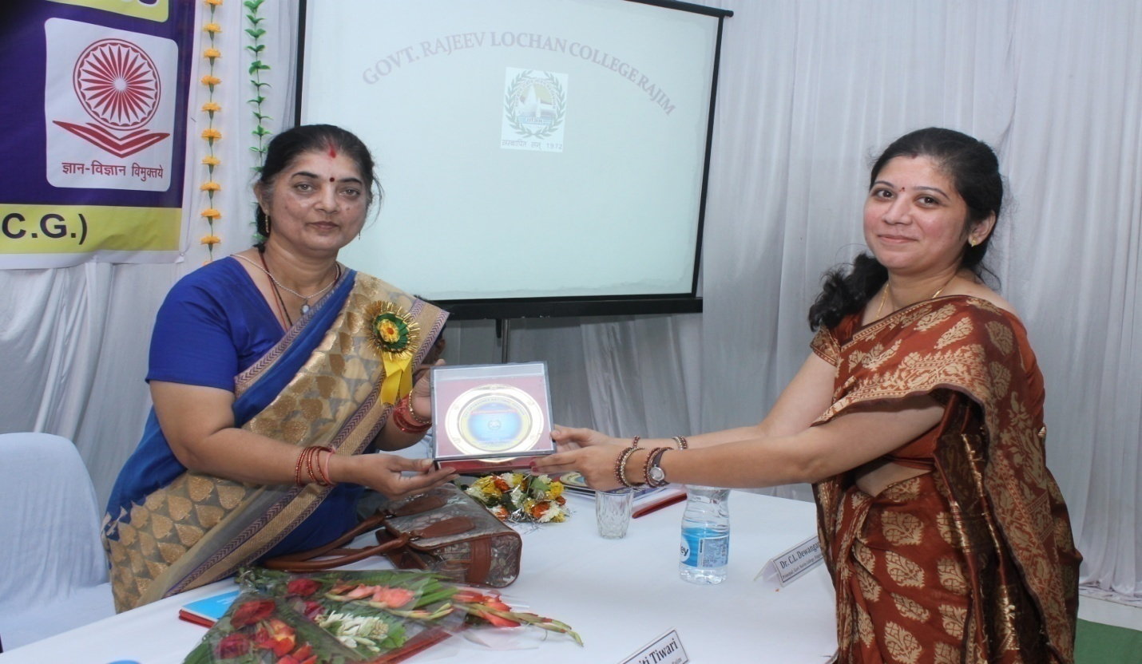
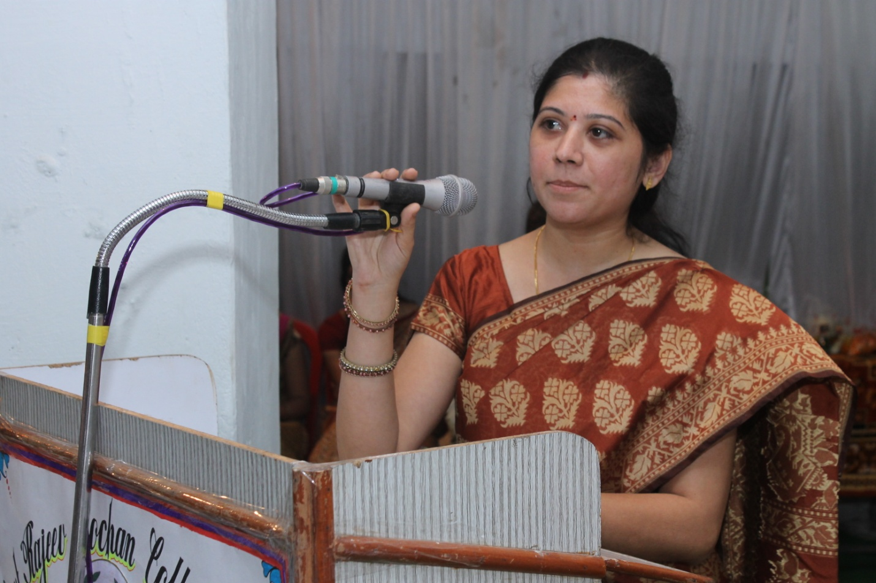
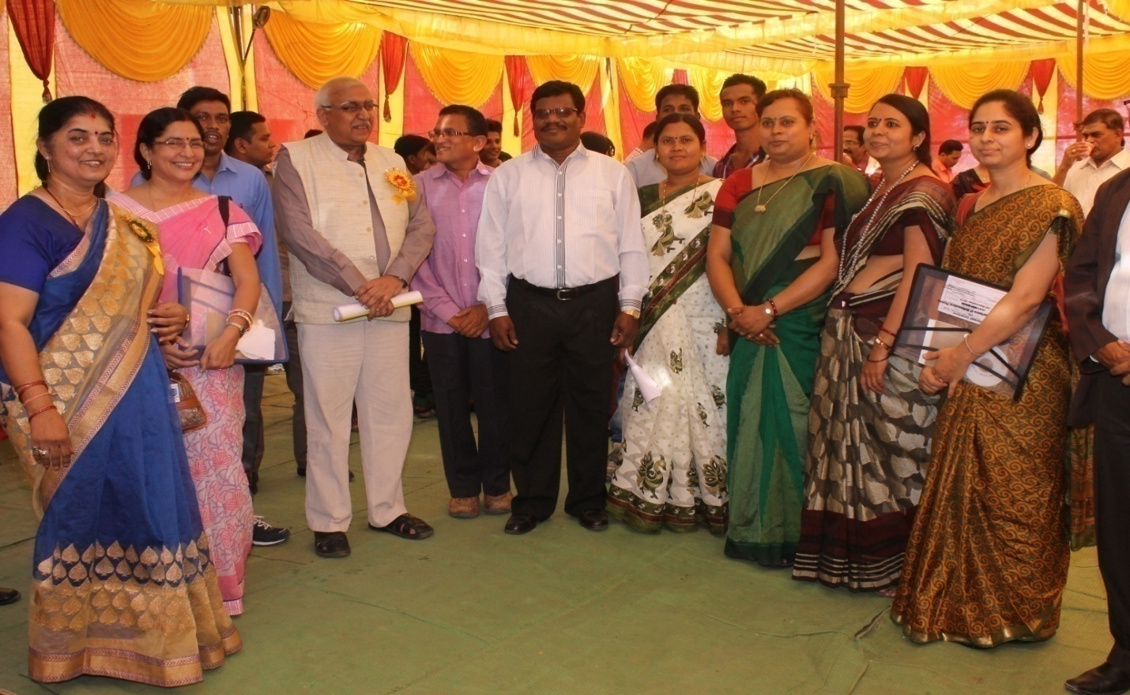
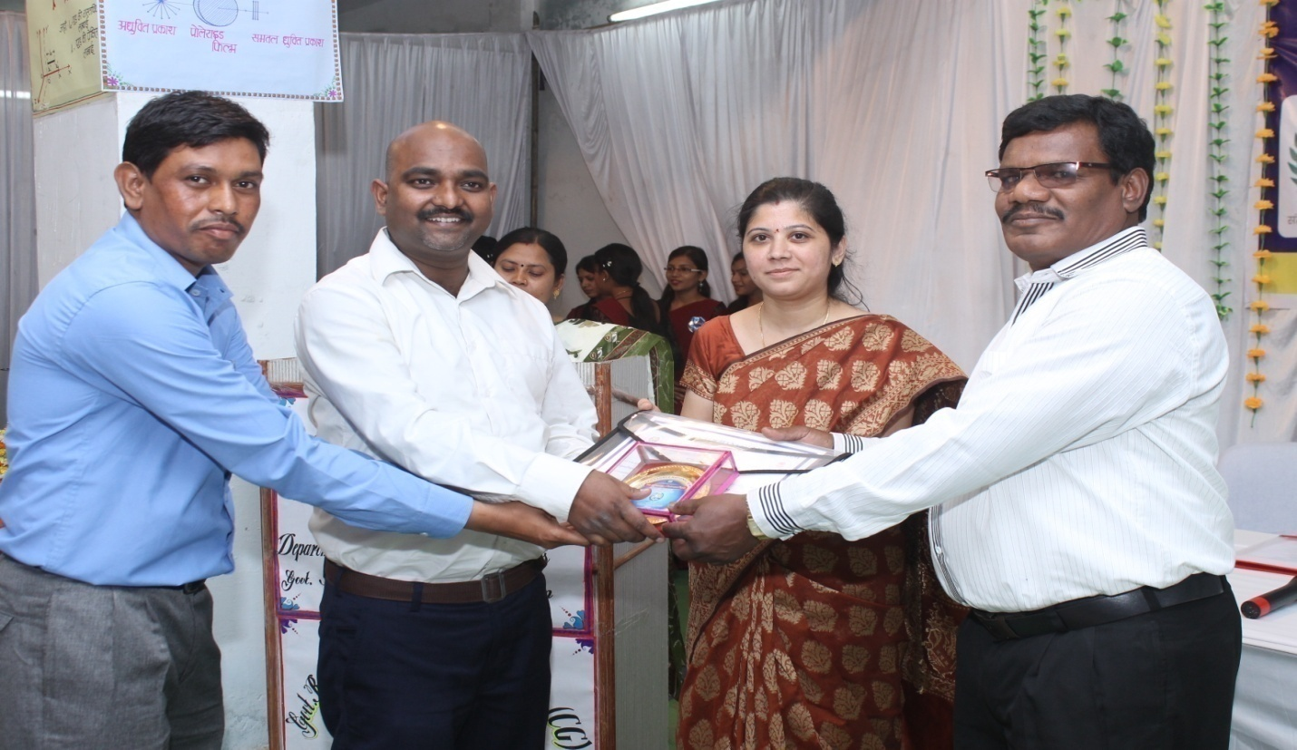

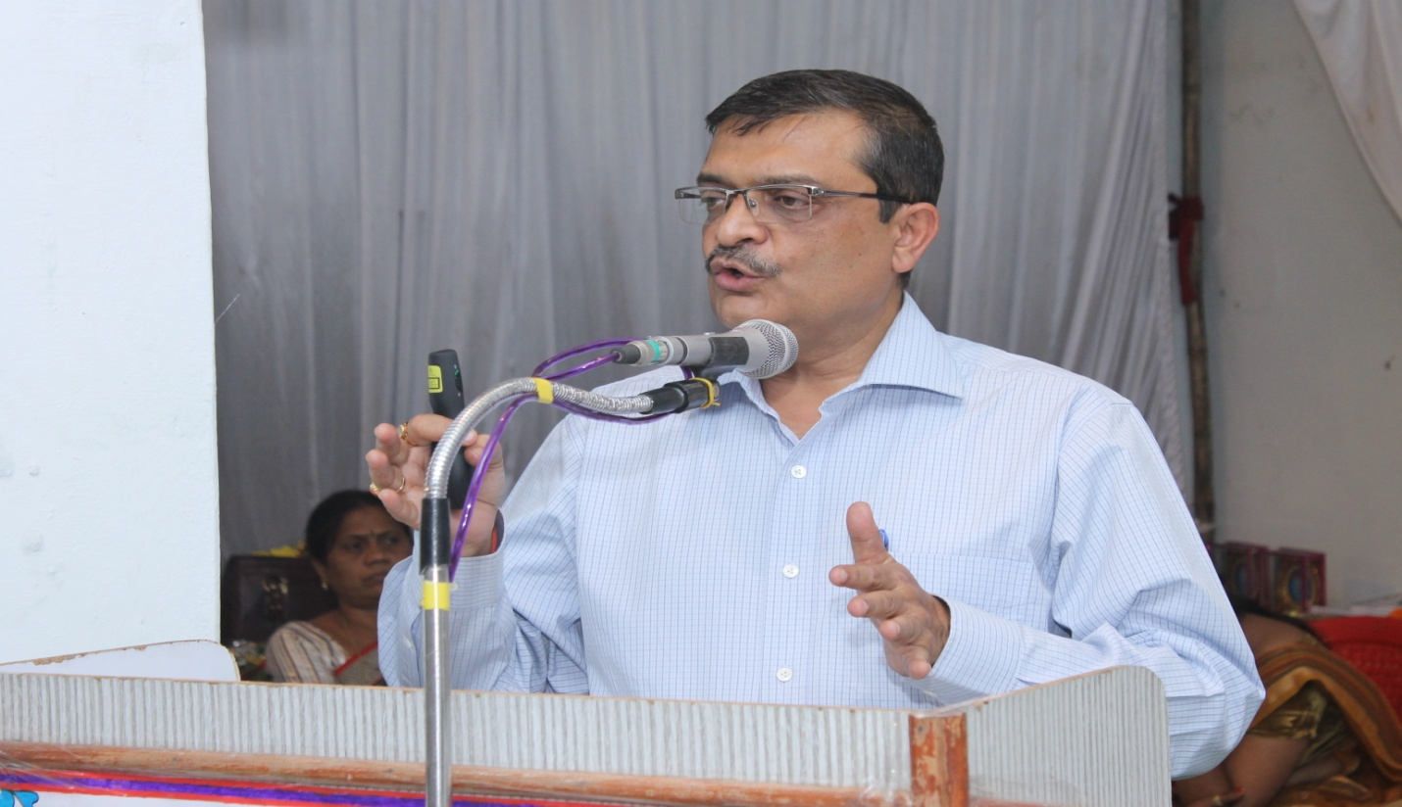
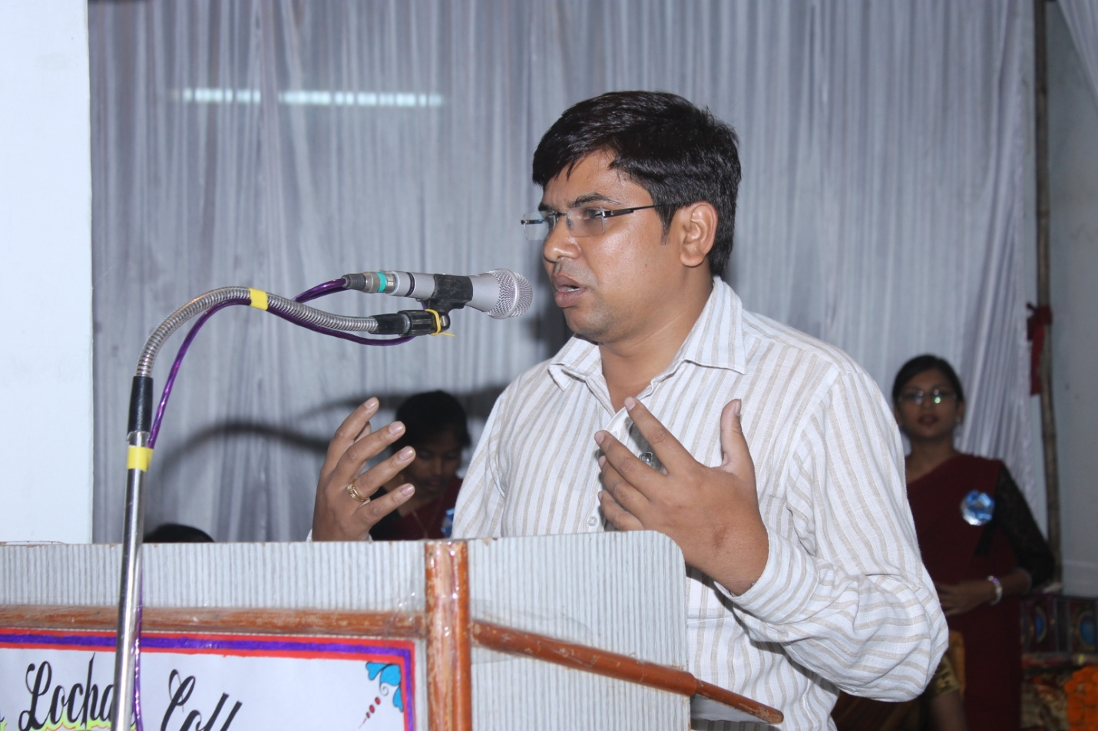
s